Fungi Trivia

* There are more than 120,000 named fungi, and many species that have not been discovered yet.
* Medicines made from fungi have been used to treat high cholesterol, multiple sclerosis, and cancer.
* Some fungi glow in the dark!
* Special kinds of fungi are

used to clean up oil spills

and toxic waste.

Joke Time

1. What did the mushroom say to the other mushroom?
2. Why did the grocer sell yeast?

**Kingdoms** are a way that scientists have developed to categorize living things. These categories are based on what living things have in common and how they differ. This system was developed over

2, 000 years ago and has changed a lot over the years. Currently there are five kingdoms in which all living things are divided:

* **Animal Kingdom**
* **Plant Kingdom**
* **Fungi Kingdom** – This

kingdom includes yeast, mushrooms, and molds.

* **Protist Kingdom** - A protist is a single celled organism with a nucleus. Algae is a protist.
* **Monera Kingdom** – A monera is a single celled organism with no nucleus. All bacteria are in this kingdom.

Did You Know …?



**Joke Answers:**

1. You’re a fun guy (fungi).
2. He needed to raise some dough.

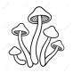

For more agricultural education lessons and resources, visit: **www.maefonline.com**

Links to Agriculture

**Yeast is a Fun-Gi**

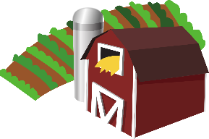

[This Photo](https://en.wikipedia.org/wiki/File:Gnome-applications-science.svg) by Unknown Author is licensed under [CC BY-SA](https://creativecommons.org/licenses/by-sa/3.0/)



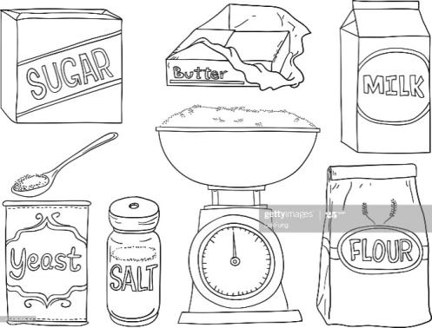**What is yeast?**

**Yeast** has been used for baking bread for thousands of years. Yeast is unlike most other baking ingredients because it is alive. It is a type of **fungus**. Prior to 1969, living things were classified as either plants or animals. **Fungi** (plural form of fungus) were classified as plants. Most plants can make their own food.

However, fungi like yeast are different and need to get their food from other sources. That is why fungi are now considered to be a separate category or **kingdom**, scientifically speaking.

**How does yeast work?**

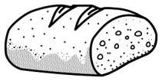Like other living things, yeast needs food or fuel to grow. In a bread recipe, the fuel for the yeast is usually in the form of a sweetener. It could be sugar, molasses, honey, or even apple juice. To speed up the growth of the yeast, warm water is added. As the yeast feeds on the sweetener, a gas called **carbon dioxide** is released. Flour is added to the recipe to capture the gas produced by the yeast’s interaction with the sweetener and the warm water. As the bread begins to rise, the gas is captured in the dough. If you look carefully at bread, you will see the small holes where the spaces were filled with carbon dioxide.

**How is yeast used?**

Yeast is primarily used for baking. In addition to breads, yeast is often found in crackers and cereals. Yeast can also be found in yogurt, cheese, vinegar, mayonnaise, tomato sauce, soft drinks, and chocolate.

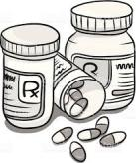

Scientists have found other uses for yeast. Scientists study yeast cells to learn more about human genetics. Because yeast turns sugar into ethanol, it can also be used to create biofuels. Biofuels are better for the environment that fuels made from crude oil. Yeast is also used in the production of some medicines.

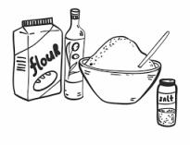

**How Well Did You Read?**

1. How is yeast different from most baking ingredients?

______________________________________________________

______________________________________________________

1. How are fungi different from plants?

______________________________________________________

______________________________________________________

1. Draw lines to match each baking ingredient to the job it performs.

|  |  |
| --- | --- |
| * sugar | * speeds up growth of yeast |
| * warm water | * captures carbon dioxide |
| * carbon dioxide | * provides fuel for yeast |
| * flour | * causes bread to rise |

1. In addition to food production, what are other ways that people use yeast?

______________________________________________________

______________________________________________________

______________________________________________________

**Grow Your Own Fungi**

You have experimented with **yeast**, a living organism and type

of fungi. In this experiment you will grow **mold**, another type of

fungi, and discover which environment encourages rapid growth.

***Please note:* It is important that you do not touch the mold that grows. If you are allergic to mold, this experiment is not for you. Always get adult help for experiments.**

**Materials:**

|  |  |
| --- | --- |
| * 6 slices of white bread | * water |
| * 6 zipper lock plastic bags | * vinegar |
| * permanent marker |  |

**Directions:**

|  |  |  |
| --- | --- | --- |
| **Label the bag** | **Put in …** | **Place bag in** |
| A | one slice of dry bread | a sunny spot |
| B | one slice of dry bread | a dark place |
| C | one slice of bread sprinkled with water | a sunny spot |
| D | one slice of bread sprinkled with water | a dark place |
| E | one slice of bread sprinkled with vinegar | a sunny spot |
| F | one slice of bread sprinkled with vinegar | a dark place |

**Check the bags every day for a week and then answer these questions:**

.

1. In which bags did mold grow first? Last? Which bags grew the most mold?

1. Were the bags that grew mold in a sunny place or a dark place?
2. Were the bags that grew the most mold dry bread or wet bread?
3. When you analyze the bags, what do you determine to be the best

conditions to grow fungi?

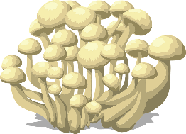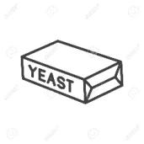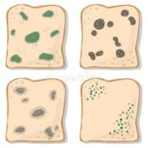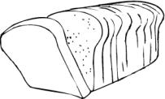

**Mushroom Farming**

Believe it or not, there are farmers who grow fungi! Mushrooms are grown indoors and are grown all year round. Unlike green plants or crops, they do not need any light to grow! Mushrooms double in size every day.