Snack Trivia

* Grapes have been grown for over 8,000 years.
* Pineapples got their name because 500 years ago an explorer thought that they looked like a pinecone.
* There may be as many as 1,000 seeds on a strawberry.
* Mozzarella is the most frequently eaten cheese.
* January 19th is

National Popcorn Day.

Joke Time

1. Why did the monster eat a light bulb?
2. What did the Invisible Man drink at snack time?



* Pears ripen best off the tree.
* Watermelons must be harvested by hand.
* Hard-boiled eggs are protein packed snacks.
* Eating snacks containing protein and fiber will make you feel full for a longer time.
* The most popular

snack nut is

the peanut.

Did You Know…?

**Joke Answers:**

1. It wanted a light snack.

2. Evaporated milk

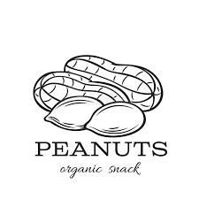

For more agricultural education lessons and resources, visit: **www.maefonline.com**

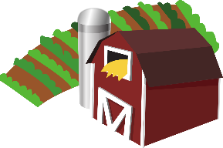

[This Photo](https://en.wikipedia.org/wiki/File:Gnome-applications-science.svg) by Unknown Author is licensed under [CC BY-SA](https://creativecommons.org/licenses/by-sa/3.0/)

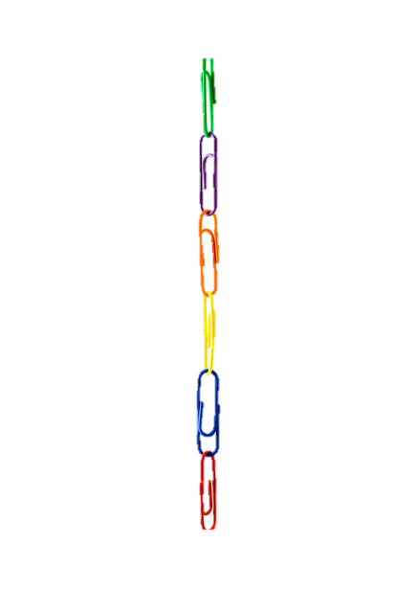

Mobile Science Lab ~ Links to Agriculture

**Snack Attack**

**Healthy Snacking**

When you get hungry between meals, you are probably looking for a snack that is quick and satisfying. Choosing the right snack can provide you with the vitamins and nutrients you need for energy. Here are some ideas for healthy snacks that you can grab fast!

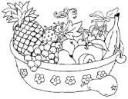**Fruit**

Fresh fruit is a wholesome way to satisfy your need for sweets. Bananas, apples, pears, grapes, peaches, and plums are examples of fresh fruit that can be eaten whole. Some fruits such as pineapple, watermelon, and cantaloupe are too big to eat whole, but they can be cut into bite size pieces and kept in ready-to-grab containers. Dried fruits such as raisins and cranberries make healthy snacks too.

**Raw Vegetables**

Raw vegetables are another excellent source of vitamins and nutrients. Carrots, peppers, broccoli, and cauliflower are examples of raw vegetables that can be cut into small pieces and eaten for snacks. Many people enjoy dipping vegetables in hummus, which is a creamy dip made from chickpeas.

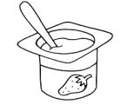

**Dairy Snacks**

Dairy products are rich in protein and calcium. Consider eating a slice of cheese, some yogurt, or cottage cheese the next time you need a snack.

**Nuts and Grains**

Unbuttered popcorn is a delicious whole grain snack that is also nutritious. Nuts and seeds contain some fat, but they are also loaded with many of the nutrients your body needs.

**Avoiding Fat, Salt and Sugar**

Chips, candy, cookies, and soft drinks are snacks that should be saved for special occasions, maybe once or twice a week. Most types of chips have large amounts of fat and salt. Cookies are loaded with fat and sugar. You don’t have to cut out the goodies all together, but you should make sure you don’t eat more of these foods than anything else.

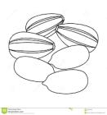

**Making Healthy Choices**

Try to eat a variety of different types of snacks. Avoid eating too many snacks that contain fat, salt, and sugar. Happy Snacking!



**“Ag” Snacks**

Raising animals and growing crops is what

Agriculture is all about. Here are some snack ideas

that use fruit (crops) to make fun farm animals.

**Peachy Pig**  
**Ingredients**

* 1 Peach
* Raisins

**Directions**

Ask an adult to help. Start out by washing your peach & then cutting it in half using a knife. Cut a little bit more from one half. This will be the head & you will use the cut off slice to make the ears, nose, & feet. Cut raisins in half to make the nostrils, mouth, eyes, & tail. Place raisins on the bottom of your plate to look like mud.

**Sheep Fruit Snacks**

**Ingredients**

* 1 Banana
* 1 Raisin
* 1 Mini Marshmallow
* Black Grapes
* Green Grapes

**Directions**

Ask an adult to help. Start out by cutting a hand full of dark & green grapes in half using a knife. Cut the banana into thin slices. Place the green grapes on the bottom to look like grass. Then arrange the banana slices in a circle on top for the sheep. Add the black grape halves in the middle for the face & add 2 grape halves to the bottom for feet. We cut a mini marshmallow in half for the eyes & cut a raisin in half for the pupils. We also used 2 white sprinkles for the nose.

Recipes courtesy of <https://kitchenfunwithmy3sons.com/>

**How Well Did You Read?**

1. What are three ingredients that should be

avoided when choosing a healthy snack?

__________ __________ __________

1. How do vitamins and nutrients help people?

______________________________________________________

1. What are dairy products rich in?

______________________________________________________

1. Plan a “snack menu” for the week. Remember to eat a variety of foods and keep most of your snacks healthy.

|  |  |  |
| --- | --- | --- |
|  | **Morning Snack** | **Afternoon Snack** |
| Sunday |  |  |
| Monday |  |  |
| Tuesday |  |  |
| Wednesday |  |  |
| Thursday |  |  |
| Friday |  |  |
| Saturday |  |  |



