Links to Agriculture

**On Solid Ground with Soil**

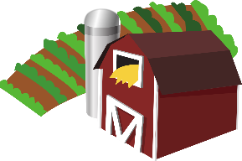

[This Photo](https://en.wikipedia.org/wiki/File:Gnome-applications-science.svg) by Unknown Author is licensed under [CC BY-SA](https://creativecommons.org/licenses/by-sa/3.0/)



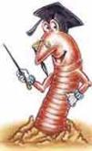

**“Worm”** your way through these questions

answered by a friendly worm from the

USDA Natural Resources Conservation Service.

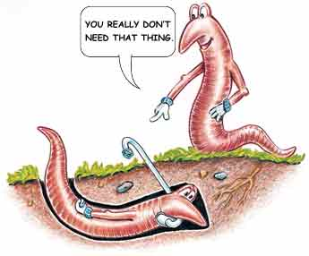**1.How does air get down into the soil?**

Air gets down into the soil through the same pores that let in and hold water. The burrows that my pals and I dig let in air, too. That’s good news for under grounders who need air. By the way, I don’t have lungs for breathing. I breathe through my skin.

**2.What does weather do to soil?**

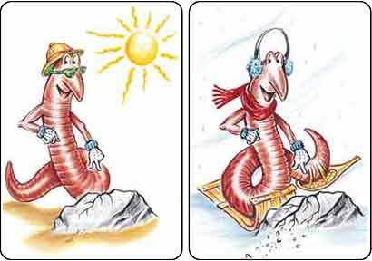Whether you believe it or not, weather helps make soil. When the weather gets hot, rocks can get bigger. When the weather turns cold, rocks can get smaller. If this happens often enough, the rock will crack and break up into small pieces that break into even smaller pieces. When they get really small, they turn into soil. Rain and ice can also get into rocks and break them apart. So, believe me, the weather does help make soil. And that's no snow job.

**3. Do soils come in different colors?**

#### They sure do! Soils can come in black, red, yellow, white, brown, and gray. Not exactly a rainbow of colors, but they look good to me!



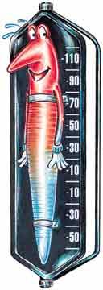

**4. How does soil help me keep me cool?**

I'm cool. If the temperature gets too cool, I can dig deeper to find a warm place to slither and snooze. But when the temperature is too hot, I don't feel so hot. In fact, if I get too hot, I'll dry up like a piece of old beef jerky. So, on really hot days, I look for a cool spot in the soil and coil myself up to keep cool and stay moist.

#### 5. Why do plants like soil?

#### Because plants like to eat and drink. Soil has a lot of the things that plants need to satisfy their appetites. But not for pizza or banana splits. Those are too big to fit in the plant's roots. Plants have a hunger for nutrients with really strange names that you'll learn in high school.

Worm cartoons and text taken from

USDA Natural Resources Conservation Service website.

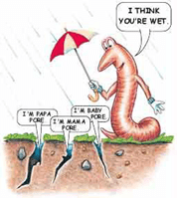**6. How does water stay in the soil?**

When water gets into the soil, it pours into pores. Pores are spaces in the soil that come in different sizes. The bigger the pore, the more water it holds.

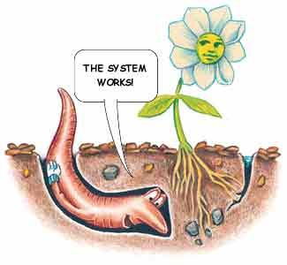

**7. Do roots help just plants?**

No way! Roots love helping others. They drain water from the soil. That keeps the soil from staying too wet. And when the soil gets too dry, roots draw up water. This water has all kinds of good stuff in it that living things need to stay healthy. Roots help make soil, too. They split rocks into pieces that later become soil.



**How Well Did You Read?**

1. How does soil help plants?

_____________________________________________________________________________________________

_____________________________________________________________________________________________

_____________________________________________________________________________________________

1. How do plants help soil?

_____________________________________________________________________________________________

_____________________________________________________________________________________________

_____________________________________________________________________________________________

**Soil Trivia**

* Of all the planets, only Earth has soil.
* It takes between 200 and 1,000 years to make 1 inch of topsoil.
* The largest earthworm ever found was in South America and measured 22 feet from its nose to the tip of its tail.
* One cup of soil holds

about 6 billion

organisms.

Joke Time

1. What is worse than finding a worm in your apple?
2. What is smarter than a talking worm?



* Farmers plants cover crops to keep soil from washing away.
* Farmers plant trees along the edges of a field or stream to keep soil from eroding.
* Farmers rotate their crops to keep the soil healthy.
* Farmers test their soil so

they know the exact

amount of fertilizer

needed.

**Did You Know…?**

**Joke Answer:**

1. Finding half of a worm

2. A spelling bee

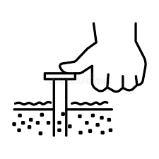

For more agricultural education lessons and resources, visit: **www.maefonline.com**