Links to Agriculture

**Hydroponics**

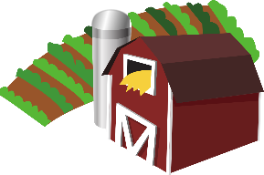

[This Photo](https://en.wikipedia.org/wiki/File:Gnome-applications-science.svg) by Unknown Author is licensed under [CC BY-SA](https://creativecommons.org/licenses/by-sa/3.0/)



Plants require some basic things to grow and thrive. They need water, light, air, nutrients, and structural support for the roots. Traditional methods for growing plants use soil to provide the water, nutrients, oxygen, and root support.

**Hydroponics** is a system for growing plants that does not use soil. Plants are grown in water which has nutrients mixed into it. Hydroponic systems must include a way to provide oxygen to the roots and a way for the plant to anchor itself.

The practice of growing plants in water is not new. As far back as 1627, a man named Francis Bacon wrote a book about growing plants in water without soil, but gardens in water have existed prior to this. Growing plants in water is documented in ancient & historical records from China, Egypt, and even from the Aztecs of Central America. In the United States, at the University of California, William Gericke promoted the practice as early as 1929.

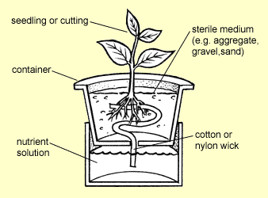

There are two main types of hydroponic systems. **Passive** systems use no energy to move nutrients and water. Passive systems often use a “wicking” material to bring the liquid nutrients up to the roots, or they suspend the plants in the solution with an air space around some of the roots. **Active** systems rely on energy (usually an electric pump) to move the nutrients in and out of the root area and to provide oxygen. Systems with pumps that deliver oxygen to roots tend to produce healthier plants more quickly than passive systems.

Passive System

There are many advantages to growing crops hydroponically.

* Hydroponic plants can be grown anywhere. Hydroponic greenhouses can be built in climates where outdoor farming is not possible.
* Hydroponic plants often grow faster than those grown using traditional methods. Plants grown in hydroponic greenhouses can also be grown year-round and are not as affected by weather. Growing plants faster and year-round increases the amount of food produced.
* 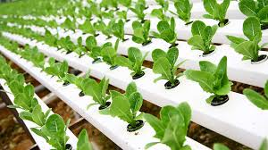Hydroponic systems use 90% less water than traditional systems which lose much of the water used into the ground. It is a great system for countries where water scarcity is an issue.

It is easy to see why hydroponics is one of the fastest

growing method of food cultivation in the world!



**How Well Did You Read?**

1. What is the author’s purpose for writing this article?

______________________________________________________________

______________________________________________________________

______________________________________________________________

1. How do hydroponic systems differ from traditional systems for growing plants?

______________________________________________________________

______________________________________________________________

1. What are two advantages of hydroponic growing systems?

______________________________________________________________

______________________________________________________________

______________________________________________________________

1. Why do you think hydroponics is not used in all farming? What might be some reasons all farmers have not switched to hydroponics?

______________________________________________________________

______________________________________________________________

______________________________________________________________

______________________________________________________________

______________________________________________________________

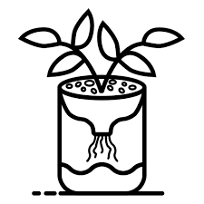



**Growing Herb Plants in Water**

**Materials:**

* Herbs
* sharp scissors
* glass jars or bottles
* spring water or well water

**Directions:**

1. Choose your plants. The following herbs grow well in water: basil, oregano, thyme, mint, sage, and rosemary.
2. Cut a piece of an existing plant just below a leaf,

leaving the stem in place.

1. Put the cut piece in a glass jar or bottle.

Choose a jar that will support the stem of the plant.

1. Add water. The water you use is important. Spring water or well water has higher levels of nutrients than city water.
2. Place the jar in an area where it will get

some light.

1. Refill the water when about half of it

evaporates.

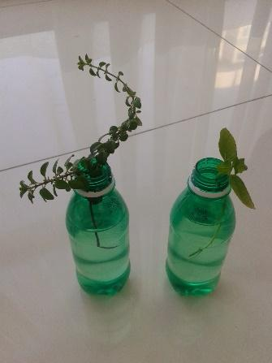

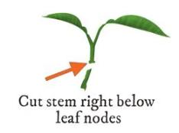

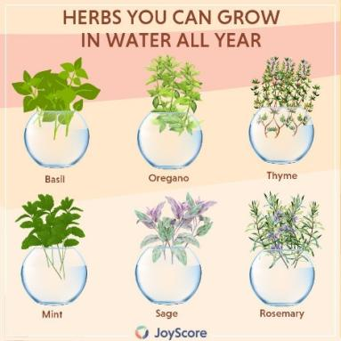

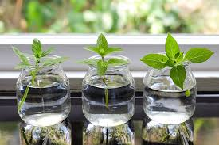

**Hydroponics Trivia**

* Hydroponics gets its name from the two Greek words hydro, meaning water, and ponics, meaning labor.
* Commonly grown hydroponic plants are tomatoes, cucumbers, strawberries, and lettuce.
* With hydroponics, you can grow four times as many plants in the same space as traditional soil farming.

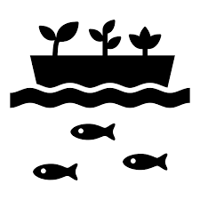

* NASA has experimented with hydroponics since it may be one of the main options for growing food in space for future space missions or for manned missions to the moon or Mars.
* Aquaponics is a variation of hydroponics, where fish and plants live within the same system. The waste that the fish produce provides the nutrients that the plants need to grow. The plants and beneficial bacteria within the system purify the water, ensuring that the fish continue to have a healthy environment to live in.

1. Why was the tomato on a motor bike?
2. Why was the little strawberry crying?
3. She was trying to ketchup with her friends.
4. His mom was in a jam.

**Joke Answer:**

**Did You Know …?**

For more agricultural education lessons and resources, visit: **www.maefonline.com**