Links to Agriculture
Bug Out with Beneficial Insects
This Photo by Unknown Author is licensed under CC BY-SA

For many years, farmers have depended on pesticides to help them grow bountiful crops. But pesticides are expensive, and they may kill beneficial insects as well as harmful insects. If a person isn’t careful, pesticides may get into the water we drink.

For these reasons, many farmers looked for a new way to control insects. Instead of just spraying pesticides on their fields, they try several methods of pest control. This is called Integrated Pest Management or IPM.

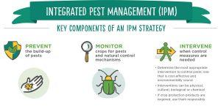
Farmers “scout” their fields to find out how many and what kind of insects are there. One method of insect control is crop rotation. If a farmer grows a different crop in his/her field each year, the pests/insects may be fooled into staying away. That’s because different pests attack different crops. Crop rotation keeps pest populations from growing too much in one field from year to year.

Encouraging beneficial insects is another kind of pest control. Farmers need to know which insects are beneficial. Two familiar beneficial insects are bees and ladybugs.
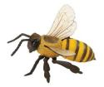
Honeybees fly at about 7 miles per hour. They must beat their wings 190 times per second to do it. The buzzing of bees is the sound of their wings moving up and down at a rapid rate.

Bees couldn’t live without flowers, and flowers couldn’t live without bees. All of the bees’ food comes from flowers. They suck nectar from flowers with their long tongues. They also collect pollen that flowers make. Some of the pollen that gets on the bees is carried from one flower to another. This is how many of the fruits we enjoy are pollinated. Frequently, a farmer will rent
beehives for the orchard to assure pollination of peaches, apples, strawberries, and other fruits.

Honeybees have special body parts for making wax. About 8 million pounds of beeswax are used in the United States each year. People use beeswax to make candles, lipsticks, cold creams, ointments, lotions, shoe polish, crayons, chewing gum, and floor wax. Honeybees also produce honey which is used to sweeten many foods. The many trips honeybees travel to produce a pound of honey is equal to about twice the distance around the world!
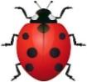
The ladybug is one of the farmer’s best friends. Its larvae eat other insects like aphids that cause a lot of damage to crops and garden plants. Ladybugs have a hard outer pair of wings that serve as a protective covering for the fragile wings they use for flying. Lady bugs use their antennae for tasting, smelling, and touching.

What Did You Learn?
Choose the best answer or answers.

- What does IPM stand for?
  - Initial Pest Management
  - Integrated Pest Management
  - Independent Pest Management

- How are honeybees beneficial insects? Choose all that apply.
  - Pollinating
  - Eating insect pests
  - Making beeswax
  - Making honey

- The article ends without a conclusion sentence. After reading the article, write a concluding sentence that wraps up the main ideas. A sentence has been started for you.

“As you can see, _________________________________________________
_______________________________________________________________”

State Insects
Many states have officially designated state insects.
Use the information on this chart to complete the State Insect Activity Page.

State | Insect | State | Insect
Alabama | Monarch Butterfly | Missouri | Honeybee
California | Dog-Faced Butterfly | Nebraska | Honeybee
Connecticut | Praying Mantis | New Hampshire | Ladybug
Delaware | Convergent Lady Beetle | New Jersey | Honeybee
Georgia | Honeybee | New York | Ladybug
Illinois | Monarch Butterfly | North Carolina | Honeybee
Iowa | Monarch Butterfly | Ohio | Ladybug
Kansas | Honeybee | Oregon | Swallowtail Butterfly
Maryland | Baltimore Checker Spot Butterfly | Pennsylvania | Firefly
Louisiana | Honeybee | Tennessee | Firefly
Maine | Honeybee | Utah | Honeybee
Massachusetts | Ladybug | Vermont | Tiger Swallowtail Butterfly
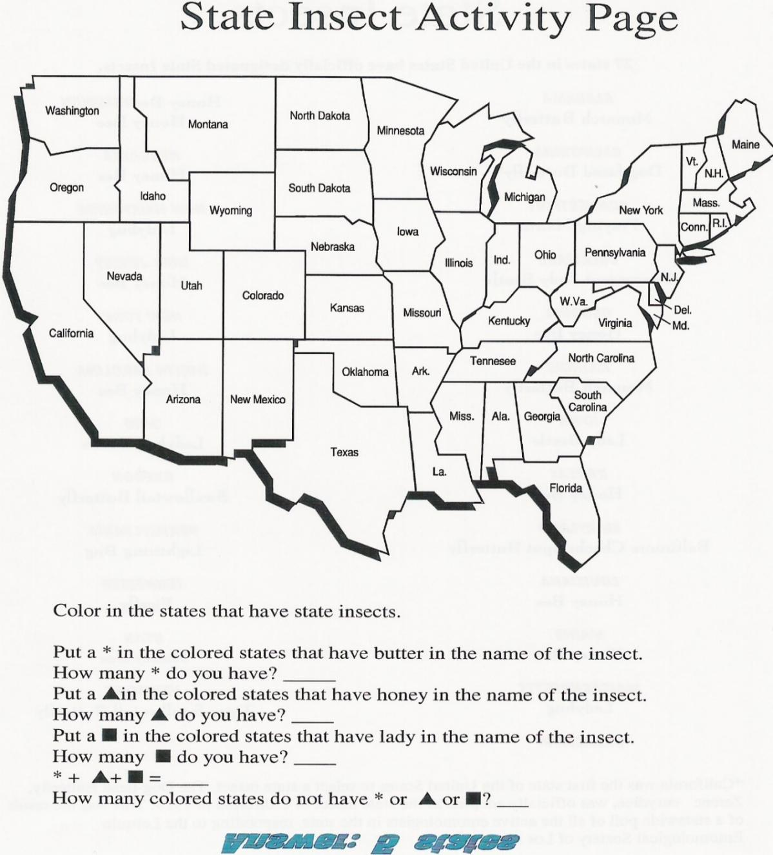

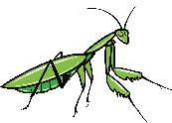
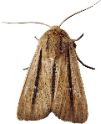
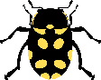
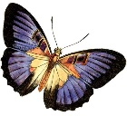

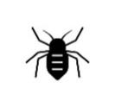
A Glasshopper

Did You Know…?

- To help protect against pests, some farmers use pest resistant seeds when they plant cotton,
corn, or soybeans.

- Spraying garden plants with a mixture of water and dish soap can help to keep pests away.

- Peppermint plants and lavender plants can be used in the garden to repel pests.

Bug Trivia
- You will never get bitten by a male mosquito. Only the females bite!

- Grasshoppers existed before dinosaurs!

- Lightning bugs or fireflies are not true bugs or flies. They are actually beetles.

- Fruit flies were the first living creatures to be sent into space.

- A bee’s wings beat about
11,400 times a minute.
For more agricultural education lessons and resources, visit: www.maefonline.com
Joke Answer:
What do you call a bug that jumps over cups?

Joke Time

