A Daily Dose of Dairy

Ag in 10 Minutes a Day!

“Drink your milk so you can grow up big and strong!” You may have heard folks say this. It is true, milk is an excellent source of many important nutrients that we need to grow and maintain a healthy lifestyle. Humans have been drinking milk for thousands of years. Most of the milk that we get comes from cows that are raised on a dairy farm.

What does a Dairy Farmer do?

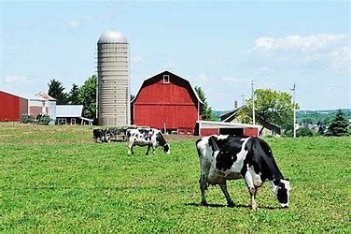
A day on a dairy farm is remarkably busy. Most dairy farms are family businesses that stay in the family for generations. Farmers work every day and are usually up before the sun! The cows need to be cared for, so there is never a day off, even on weekends.

Dairy farmers milk their cows at least two, and sometimes three times daily. This process is usually done with a milking machine, which can milk a cow in about five minutes. Of course, the farmer is responsible for connecting the machines, cleaning, and disinfecting the machine and the cow’s udders, and making sure that the milk is properly stored in sanitized tanks for pickup.
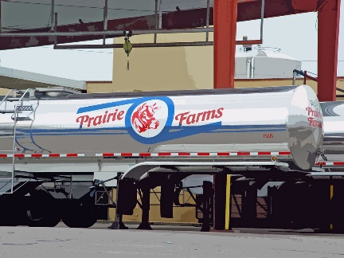
Milk is picked up every 1 to 2 days from farms in large tanker trucks and heads to a processor. All milk collected is tested for safety and any milk that doesn’t pass is dumped and the farmer does not get paid for it. Milk that passes all tests is then pasteurized and packaged for sale. Pasteurizing is heating the milk to kill harmful bacteria, so the milk is safe to drink. Milk processors and farmers take the safety of their milk very seriously.

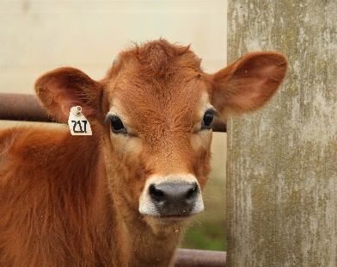
In addition to milking the cows, the farmers must feed and water them, and keep them clean. Dairy cows will eat about 100 pounds of food and drink about 35 gallons of water each day! Most cows eat a combination of grass, hay, and grains. The quality of their diet affects the amount and quality of milk they make. Cows produce about 7 gallons of milk every day. They also produce about 15 piles of poop or manure, or about 65 pounds worth, that somebody must pick up!

All that manure does not go to waste! Many dairy farmers also grow crops to feed their cows like corn, alfalfa, or wheat. Farmers must be incredibly careful with how they handle the manure that their cows produce. Manure is full of nutrients that crops need to grow, so most farmers keep a manure pit and mix in the manure in safe amounts and at proper times during the year on their fields before they plant new crops. They give the soil some added time to process the nutrients and get them ready for new plants to use them in growth.

Too much manure is dangerous for the watershed since rain will cause the nutrients to get into the streams and rivers. Manure storage facilities like manure pits or sheds offer a place for manure storage safe from rain. Then, farmers sell the excess to other farms. Some farmers even have systems to capture the methane from the manure and convert it into energy!

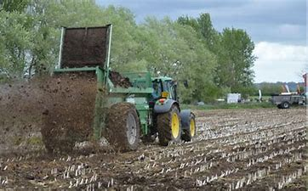

What are the Different Types of Dairy Cows?

Have you ever heard someone say that brown cows make chocolate milk? While that sounds like an easy way to get a tasty drink, it’s simply not true. Believe it or not, different breeds of cows do have different strengths when it comes to dairy.

There are around 800 different breeds of cows, but only a few are used for U.S. dairy production. About 90% of dairy cows are the black and white spotted Holstein cows. They produce more milk than any other breed and are very versatile. The Jersey cow is the next most popular. Jersey cows make milk that is higher in protein and fat. Because of that, they are more often used for products like cheese, butter, and ice cream.

Other cows used for dairy production include Brown Swiss, Guernsey (pronounced ‘gurn-zee), and Ayrshire (pronounced ‘air-shur). They each have special characteristics that make them ideal for a particular kind of dairy farm. You can see how the different breeds of dairy cows stack up against one another when it comes to the properties of their milk.

Percent of Fat and Protein by Breed in Dairy Cattle
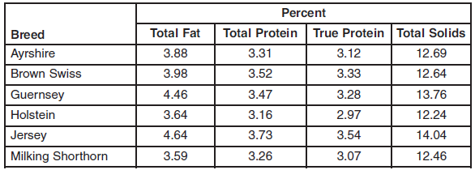
Table from “Factors Affecting Milk Composition of Lactating Cows” by Michael Looper, University of Arkansas Division of Agriculture, Research & Extension

Is Dairy Really Good for You?
Dairy products are an excellent source of calcium and protein, as well as several other important nutrients. Calcium is a mineral that makes your bones and teeth grow properly. It is also important for the functioning of your nerves and muscles. Proteins are the building blocks of all living things. If you had no protein in your diet, you would not be able to grow.
Protein provides energy, builds and repairs muscles, and can help you feel full and focused. Milk isn’t the only way we get protein and calcium into your diet. You can also eat foods that also come from farms like eggs, some cereals, tofu (from soybeans), chicken, or nuts. Check out the graphic below for good ways to start your day with protein.
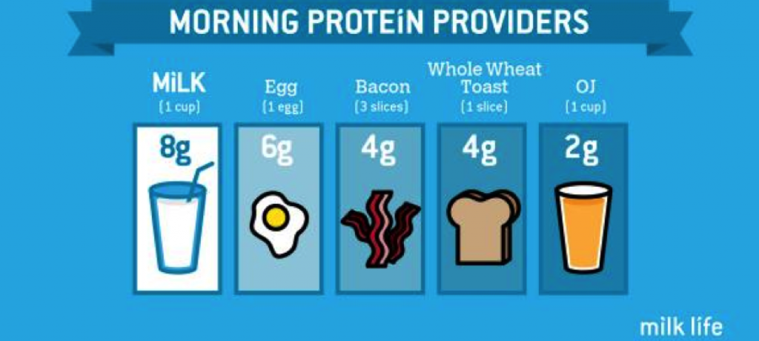
Graphic from MilkLife.com
Dairy is what we call “nutrient-dense” meaning it provides many nutrients with relatively few calories. You should try to have 3 servings of dairy every day. A serving of dairy is a cup of milk or yogurt, 1 ½ ounces of cheese, 2 cups of cottage cheese, a cup of pudding, or 1 ½ cups of ice cream (although ice cream should probably be enjoyed more as a treat). Think through your day with food - where is your dairy coming from today?

A Dose of Dairy – Reading Passage
Directions: Read each question and fill in the best answer.

- A. Adding heat
Ο B. Adding vitamins
Ο C. Adding sugar
Ο D. Adding water

- A. Important
Ο B. Nourishment
Ο C. Milk
Ο D. Mammal

2. How is pasteurization completed?
1. Which word is closest in meaning to nutrient?

3. What percent of Total Protein does milk from a Guernsey cow have?

Ο A. Paragraph 1
Ο B. Paragraph 3
Ο C. Paragraph 5
Ο D. Paragraph 7

Ο A. 4.46%
Ο B. 3.88 %
Ο C. 3.47 %
Ο D. 3.28 %

4. Where in this article can you find how much dairy cows eat and drink?

6. What could result from getting enough protein in your diet?

5. Why did the author write this article?

- A. You may want to eat
more ice cream.
Ο B. You might have a full breakfast.
Ο C. Your bones and teeth
will grow properly.
Ο D. You’ll have more energy
for your day.

- A. To inform you about dairy and dairy farms.
Ο B. To persuade you to buy milk.
Ο C. To inform you about the types of cows.
Ο D. To persuade you to become a farmer.

Extended Response: Use details from your own experience and information from the article in your response.

Imagine that you are a dairy farmer. Describe your farm using words and pictures. Make sure to include the type and number of cows, the crops you grow and products that you sell. Make sure to share how you will keep the animals healthy and protect your environment.

Try this at home! Ice Cream In A Bag
Dairy Facts
It takes 350 squirts from a cow’s udder to make one gallon of milk.
25 gallons of milk can make 9 gallons of ice cream,25 pounds of cheese or 11 pounds of butter!
A cow has 32 teeth on the bottom, but no front teeth on top – only molars in the back.
A cow spends 6 hours eating and 8 hours chewing her cud every day (cud is partially digested food that she regurgitates and chews).
(Ask an Adult First!)
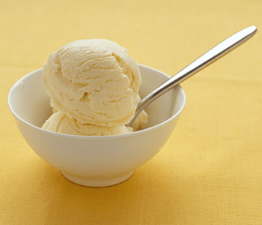
- Into a sandwich size zip lock bag, pour 1 cup of half and half, 1 ½ tsp vanilla and 1 TBSP sugar.
- Seal the bag carefully, then seal inside a second zip lock bag to prevent leaks.
- Fill a gallon size ziplock bag half full of ice cubes and add ¼ cup of salt (rock salt works best, but you can use what you have).
- Place your ice cream mixture into the large bag and seal.
- Put on gloves or use a towel to protect your hands and shake the mixture vigorously.
- Continue shaking for 5-8 minutes, or until your ice cream is frozen.
- Carefully remove from the bags and enjoy with your favorite toppings!
Check Out These Books:
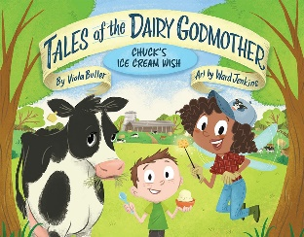  Tales of the Dairy Godmother: Chuck’s Ice Cream Wish  by Viola Butler  Join Chuck and Dairy Godmother on an adventure – one that ends with sprinkles on top! | 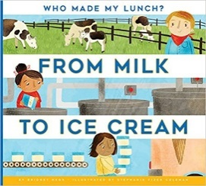  From Milk to Ice Cream  by Bridget Heos  How is ice cream made? From the dairy farm, sugarcane farm, and factory, the process is illuminated.
Extra Cheese, Please!  by Cris Peterson  Discover the process of making mozzarella cheese from cow to pizza. | 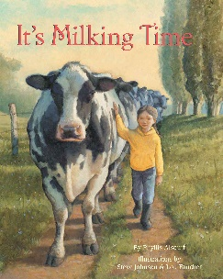  It’s Milking Time  by Phyllis Alsdurf  A story about a girl and her father working together on their dairy farm, and the bond they develop.

