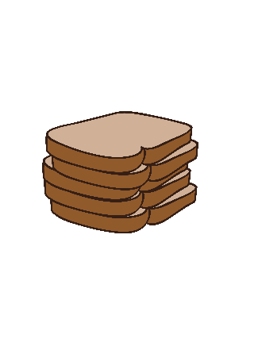
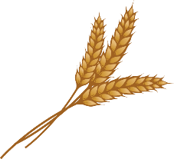
Grains are an important part of our diet. Eating grains like wheat gives us fiber, proteins & carbohydrates (for energy), and vitamin B & minerals (to make us strong and healthy).

One way to eat grains is in bread. Bread has been enjoyed by humans since very early civilizations. In fact, ancient baked loaves have been uncovered in Egyptian tombs as well as in the ruins of Pompeii. Archaeologists even discovered evidence of bread-making at an historic site in the Middle East from over 14,000 years ago.

Wheat, the essential ingredient for bread, is grown today in 42 states in the United States, including Maryland! Wheat flour is made from grinding kernels of the wheat plant.

Humans have been grinding wheat to make bread and other food for thousands of years. The early Greeks from over 2,000 years ago even had a water-powered mill which ground wheat kernels into flour. Water-powered mills like this still exist here in Maryland!

Overview/Background Info:

Wheat Grinding Activity

Wheat Grinding Activity

Materials:
- Pepper grinder (mortar/pestles may also be used, if available)
- Wheat kernels (hard red wheat seeds/berries can be purchased from the grocery store) If wheat kernels are unavailable, rice or oats may be used as a substitute.
- Bowls
Directions:
- Use the background information above to discuss the importance of bread & wheat for humans throughout history. (Additional info: Some people have medical conditions which mean that they cannot eat gluten, which is a protein found in wheat and some other grains. They, instead, eat foods made with flour from other crops like almonds or corn.)
- Place wheat kernels into the pepper grinder and grind over a bowl. Have students take turns.
- Discuss how long it takes to grind in small batches like this. Now compare and contrast how this would have been done by hand in early times (often between 2 flat stones) compared to how it is done today by machine on a large scale.
Extensions:
- Bake “Bread in a Bag”. For ingredients & instructions visit:
www.agclassroom.org/teacher/matrix/resources.cfm?rid=50
- Learn more about Maryland’s history with grinding wheat on the next page! For additional history on the Old Wye Mill, visit their webpage at:
www.oldwyemill.org
(Wheat grinding activity adapted from Virginia AITC)

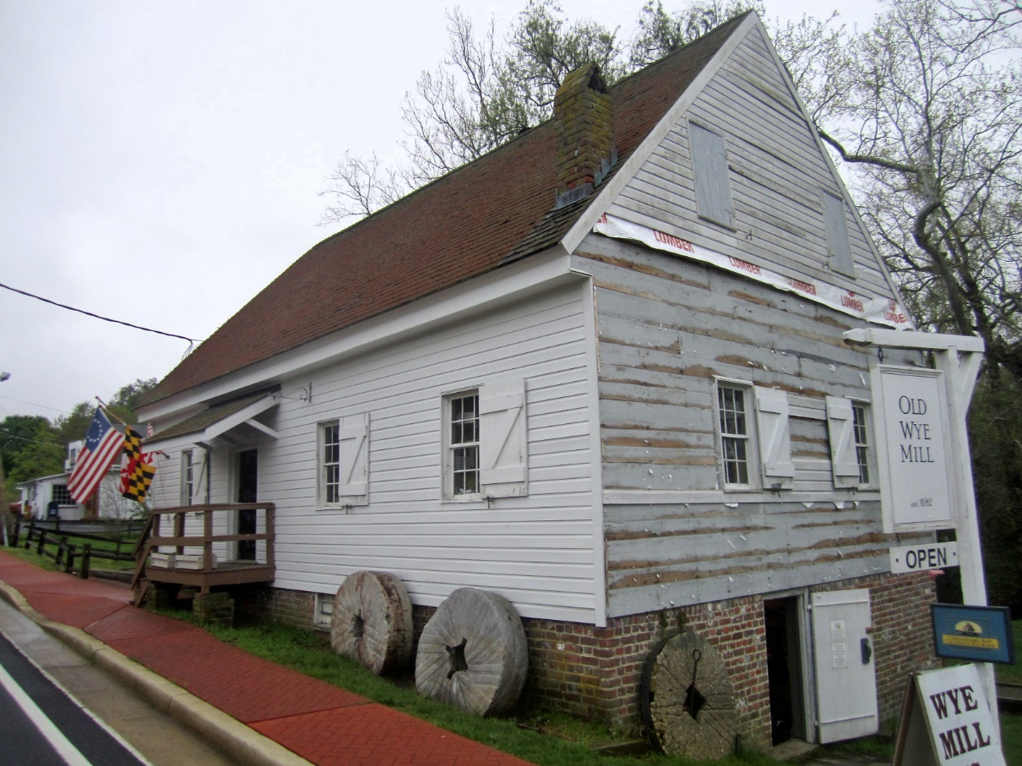
History Alive in Maryland
The Old Wye Mill, pictured here, is one of the oldest continuously operating water-powered mills in the country. It’s right here in Maryland, on the Eastern Shore!
The three stone wheels out front are examples of the type of stone wheel they use to grind grain like wheat and corn.

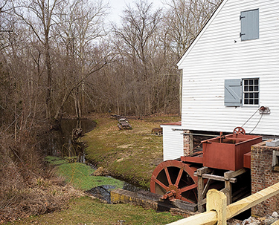
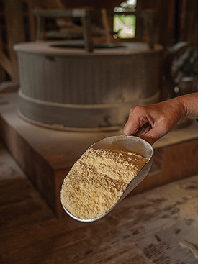
The water wheel, pictured above, turns because of the water flowing underneath of it. The wheel is connected to gears and conveyor belts, or elevators, inside which take grain up to the grinding wheels.

The 2 grinding stones inside (pictured behind the scoop of flour) rub the grains and turn them into flour or cornmeal. It’s like if you rubbed wheat kernels between two rocks to crush them, but much bigger! Each wheel weighs between 1,800 to 2,600 pounds. That’s almost the weight of a small car!
Images courtesy of Flickr (Paul McClure) & The Bay Journal.

