**Directions**: **Draw the ingredients for a peanut butter (or nut/seed butter) & jelly sandwich in the correct places on the plate. Then, read the directions on the next page to finish your healthy plate!**

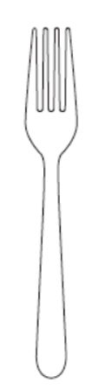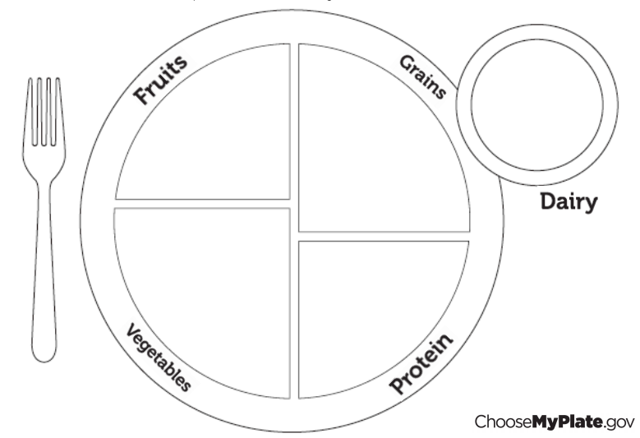

A peanut butter (or nut/seed butter) & jelly sandwich contains food from **3 of the 5** sections on the My Plate food guide.

Adapted from Virginia AITC

|  |  |  |  |  |
| --- | --- | --- | --- | --- |
| **Fruits** | **Vegetables** | **Grains** | **Protein** | **Dairy** |
|  |  |  |  |  |
| **Peaches** | **Corn** | **Oatmeal** | **Chicken** | **Milk** |
| **Watermelon** | **Carrots** |  | **Eggs** | **Cheese** |
| **Apples** | **Peas** | **Pasta** (wheat)  **Bread** (wheat) | **Hamburger** | **Yogurt** |

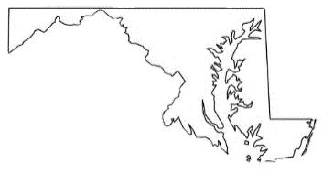

Below are pictures of some of the many foods grown or started RIGHT HERE in Maryland

by local farmers!



**Directions: Cut along the lines below & glue or place the pictures to complete your healthy plate!**

Adapted from Virginia AITC