

PB&J Hooray! by Janet Nolan

Food Sources Match & Graph, K - 1

**10th Annual Ag Literacy Program**

***I can*** *show where my food comes from on a farm.* ***I can*** *read and interpret information on a bar graph.*

***Standards Addressed:***

*K.MD.B.3, K.CC.A.1, K.CC.C.6*

*1.MD.C.4, 1.NBT.A.1, 1.NBT.B.3*

**Note for Teachers or Parents**: This activity is meant to be used either before or after reading PB&J Hooray! but it can be a standalone activity.

This activity provides an opportunity for your students to understand where their food comes from while practicing important fine-motor and math skills. Modify as needed. For some learners, dotted lines may need to be pre-drawn for students to trace once they’ve decided on the match.

**E-Learning Option**: Let your students hone their word processing skills. Choose “Insert”, “Shapes”, and select a line to show them how to click and drag a line to match their items.

Pair this activity with the following video clip from Maryland Farm & Harvest (PBS) that shows how wheat becomes flour right here in Maryland!

Watch Here (wheat clip runs from 14m55s to 19m35s – or enjoy the whole episode!):

<https://www.pbs.org/video/maryland-farm-harvest-maryland-farm-and-harvest-208/>

**Directions:** Draw a line to match the ingredients for a peanut butter and jelly sandwich with their sources from the farm. Even your sandwich comes from a farm!

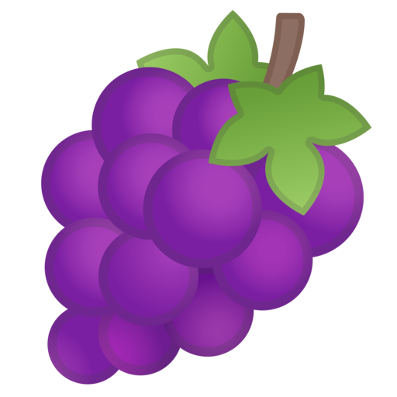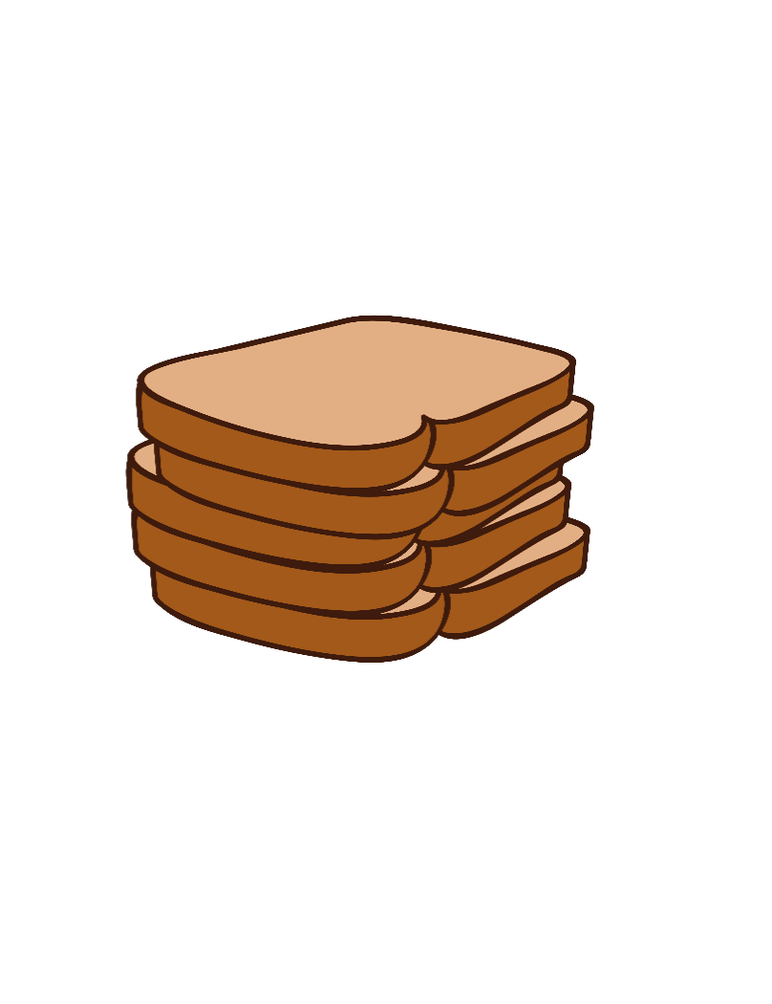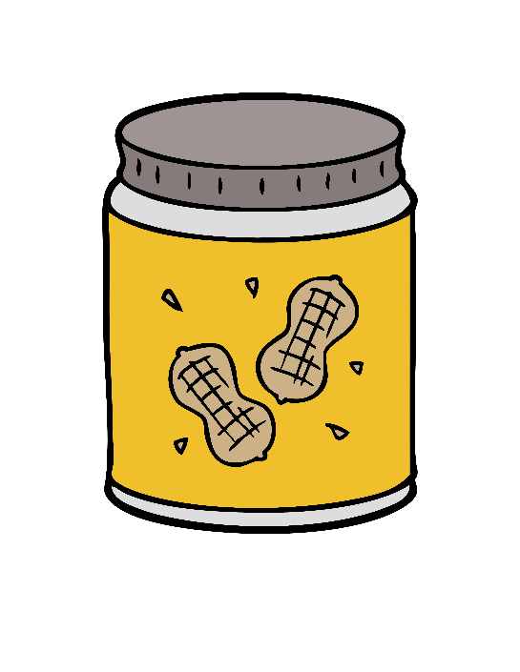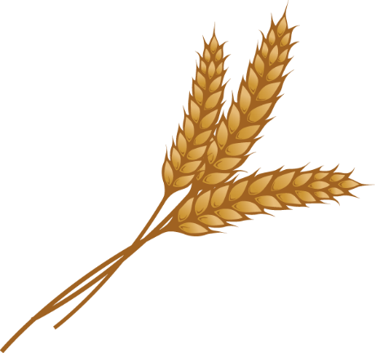

**Did you know??**

The average child will eat 1,500 peanut butter and jelly sandwiches before graduating high school. This even counts for kids who eat substitutes like sunflower butter or almond butter because of allergies.

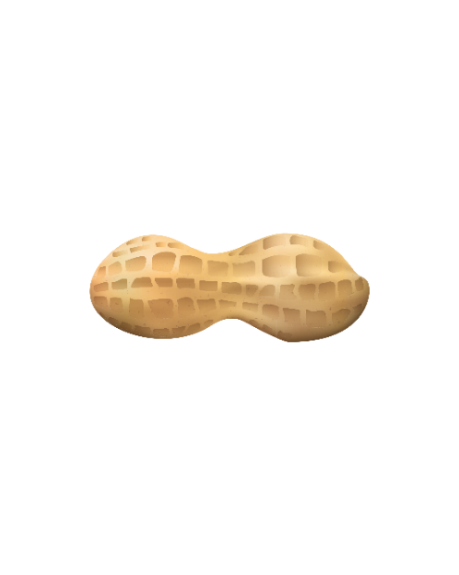

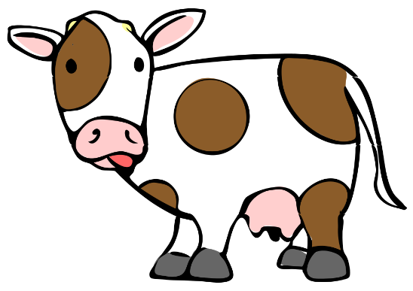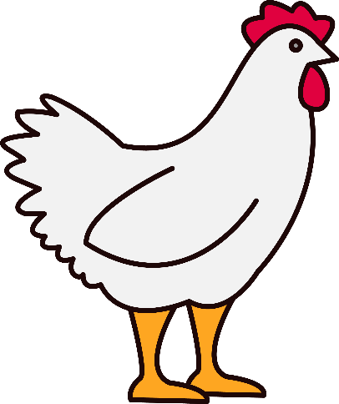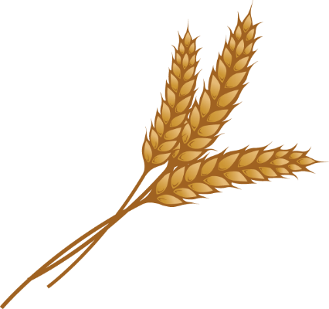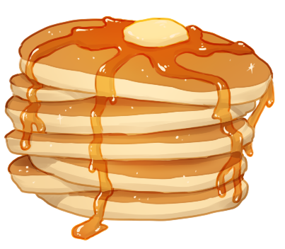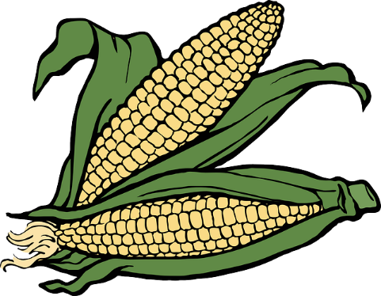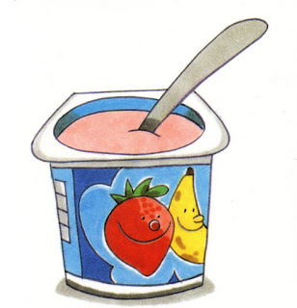

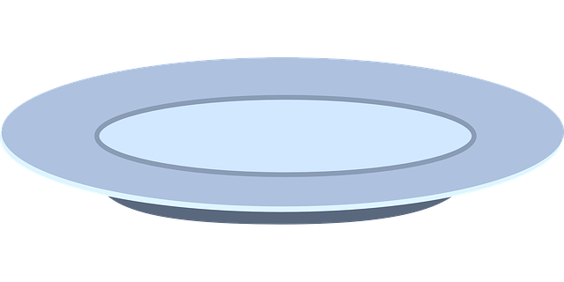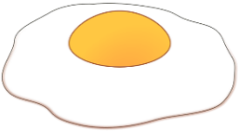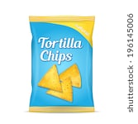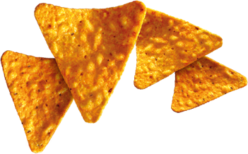

What else comes from the farm? Draw a line to match these snacks with their source from the farm.

Now, search your house or your cafeteria for items that are made from some of Maryland’s commodities. Color 1 box for each item you find made from milk (dairy cows), eggs (layer hens), and wheat.

|  |  |  |  |
| --- | --- | --- | --- |
| 12 |  |  |  |
| 11 |  |  |  |
| 10 |  |  |  |
| 9 |  |  |  |
| 8 |  |  |  |
| 7 |  |  |  |
| 6 |  |  |  |
| 5 |  |  |  |
| 4 |  |  |  |
| 3 |  |  |  |
| 2 |  |  |  |
| 1 |  |  |  |
|  | Dairy Cows | Layer Hens (eggs)    **Maryland Commodities** | Wheat |

***Teachers or Parents:*** *Use the appropriate questions for your student(s) once the graph is complete. You may wish to cut these questions out and paste them in a journal to give students enough space to show their work.*

**Kindergarten:**

1. Count the number of items in each group. Practice writing each number on the graph above each group (or ask an adult to write it and you can trace it).
2. Find the group that has the most boxes colored. Circle it on your graph.
3. Which group has more, corn or dairy cows?
4. Which group has less, wheat or eggs?

**Challenge**: Count all your data together! How many items did you find in all?

**First Grade:**

1. Count the number of items in each group. Practice writing each number on the graph above each group.
2. Find the group that has the most boxes colored. Circle it on your graph. Write it below.
3. How many more (or less) items are in your dairy group than your egg group? Show your thinking below.
4. Choose two groups from your graph. Compare them below using greater than (>), less than (<), or equal to (=).

**Challenge**: Count all of your data together. Show that number in 3 different ways below (for example: in numbers, pictures, place value blocks, as a number sentence like 10+4=14).