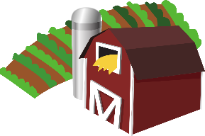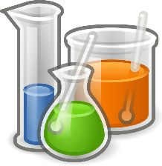

[This Photo](https://en.wikipedia.org/wiki/File:Gnome-applications-science.svg) by Unknown Author is licensed under [CC BY-SA](https://creativecommons.org/licenses/by-sa/3.0/)

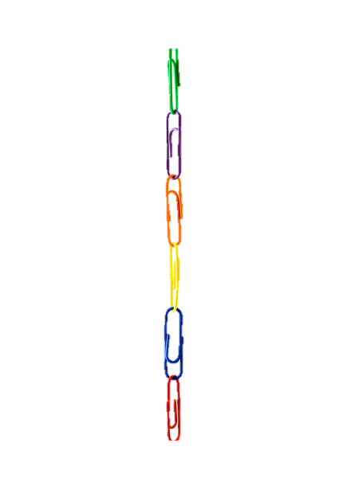

Links to Agriculture

**Corn: A Renewable Resource**

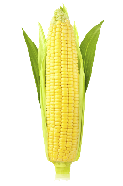

Corn (also known as **maize**) is one of nature’s most amazing energy storing plants. A corn seed weighs about one-hundredth of an ounce, yet this tiny seed can produce a corn plant that will grow 7 to 10 feet tall. One corn plant will produce between 600 and 1,000 seeds. The “seeds” are commonly known as kernels. The kernels are arranged in rows along the ear of corn. An ear of corn may have as few as eight or as many as 36 rows, but the number of rows is always even. The kernels may be saved to be planted for next year’s crop.

Corn is the major feed grain for animals raised by farmers. Corn is also a major ingredient in many of the foods we eat such as cereals, snack foods, and sodas. Corn can be found in chewing gum, ice cream, marshmallows, pickles, and chocolate products. Search your cupboards and refrigerators for even more foods made with corn.

Corn By-Products

In addition to the many food products found in the grocery store, new products are continuously being developed from corn. A **by-product** is something other than food that comes from a plant or animal. By-products from corn include items such as toothpaste, paper, soaps, vitamins, gelatin for drug capsules, body lotion, lipstick, fireworks, cleaners, and detergents.

**Biodegradable and Renewable Resources**

Corn not only provides both animals and people with food, it also has been used to develop **biodegradable** products that protect our environment. In fact, researchers have invented a biodegradable plastic made from cornstarch. Plastics made from corn will break down and not take up valuable space in our landfills.

In addition to being biodegradable, corn products are also **renewable**. This means that corn can be grown year after year. The current source of most plastic is oil, not corn. Oil based plastic does not break down or decompose, so it takes up landfill space. Plastic made from oil is also non-renewable. Once the oil reserves are depleted, they will be gone forever because we cannot make more oil.

Environmentally friendly packing peanuts are made with over 95% cornstarch. They are used to fill packages and have the benefits of being light weight, shock absorbing, and totally biodegradable.

Another environmentally friendly by-product from corn is ethanol, a high-performance fuel. It is safer for our environment because it burns cleaner and pollutes less than petroleum fuels. Since ethanol is made from a renewable resource, it can be replenished. Ethanol saves nonrenewable petroleum and makes us less dependent on oil from other countries. Researchers continue to discover new ways to use corn - a natural, biodegradable, renewable resource.

**What Did You Learn?**

1. What is a by-product?

__________________________________________________________

__________________________________________________________

1. List three by-products of corn.

_______________ _______________ _______________

1. What are the disadvantages of plastics made from oil?

__________________________________________________________

__________________________________________________________

1. Why might plastic made from corn be a good substitute for plastics made from oil?

__________________________________________________________

__________________________________________________________

1. What are the benefits of ethanol?

__________________________________________________________

__________________________________________________________



**Ooey, Gooey, Glop!**

Using only cornstarch and water, this amazing mixture

behaves like a solid and a liquid at the same time. By the

end of the activity, you will have your hands on, in, and all

over this wonderful solid-liquid-like mess!

1. Measure 3/4 cup of cornstarch into a container.
2. If you want your **glop** to be colored, add several drops of food color to ¼ cup of water.
3. Gradually add the water to the cornstarch.
4. Stir well. This will take some time and energy. Paint sticks work well for mixing.
5. Add small amounts of more water or cornstarch until you get a mixture which '**splits**' when you quickly scrape your finger through it AND THEN '**melts**' back together again. **(See disposal message at bottom of the page)**
6. Pour it onto a plate. Notice its unusual consistency. Stir it around with your finger, first slowly and then as fast as you can. Skim you finger across the top of the glop. What do you notice? Slap the liquid glop as hard as you can. What happens? Does it splash? Why does with the glop behave in this manner. What causes it to feel like something solid when you squeeze it, yet it flows like syrup as it drips off your finger?

***How does it work?***

*How does glop act like a solid sometimes and a liquid at other times? Actually, glop is an example of what is called a Non-Newtonian fluid - a fluid that defies Isaac Newton's law of viscosity. All fluids have a property known as viscosity. It is the measurable thickness or resistance to flow in a fluid. Honey and ketchup are liquids that have a high resistance to flow.   
  
 Newton stated that the viscosity of a fluid can be changed only by altering the fluid's temperature. For example, motor oil or honey flows more easily when you warm it up and becomes very thick when it gets cold. So, a Non-Newtonian fluid has the same dependence on temperature, but its viscosity can be changed by applying pressure. When you squeeze a handful of glop, its viscosity increases so it acts like a solid for a split second. When you release pressure, the glop behaves just like a liquid.*

**IMPORTANT DISPOSAL MESSAGE**: **Over time, the grains of cornstarch will separate from the water and form a solid clump. It is for this reason that you must NOT pour this mixture down the drain. It will clog the pipes and the drain. Pour the mixture into a zipper-lock bag and dispose of it in the garbage.**





Corn Trivia

* Corn is a cereal crop that is part of the grass family.
* Corn is grown on every continent except for Antarctica.
* Corn can be produced in many colors, including black, blue, purple, red, green, white, and yellow.
* There are over 3,500 uses for corn products.
* Farmers in the United States grew more than 91.7 million acres of corn in 2019.
* In 2019, one-third of the corn produced in the United States was used to feed livestock. One-third was used to make ethanol fuel.

The rest was used to

make food and

by-products for people.

Joke Time

1. What did Baby Corn say to Mama Corn?
2. What do you call a corn cob with only one kernel?

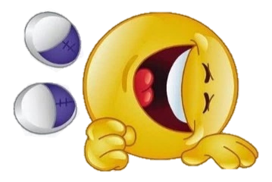

* Scientists believe that corn was first developed in Mexico more than

9000 years ago.

* Corn was so valuable to the early

settlers of North America that it was

used as money for trade.

* Corn is called “maize” by most

countries. This comes from the

Spanish word “maiz.”

**Joke Answer:**

Did You Know…?

1. Where’s Pop Corn?

2. A unicorn

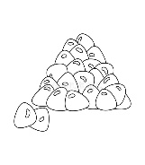

For more agricultural education lessons and resources, visit: **www.maefonline.com**