Links to Agriculture

**Clucking About Chickens**

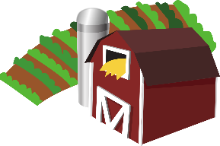

[This Photo](https://en.wikipedia.org/wiki/File:Gnome-applications-science.svg) by Unknown Author is licensed under [CC BY-SA](https://creativecommons.org/licenses/by-sa/3.0/)



Farmers raise chickens to provide **eggs** or **meat**. Female chickens are called **hens**. Male chickens are called **roosters.** Roosters have larger combs and wattles than hens and their feathers are more colorful.

A female chicken that is raised for laying eggs is called a

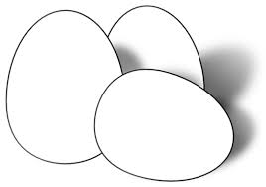**laying hen**. Hens can lay an egg every 24-26 hours. The color of an eggshell depends on the breed of hen. Rhode Island Reds and Plymouth Rock chickens lay brown eggs. White Leghorns and Brown Leghorns lay white eggs.

Chickens raised for their meat are called **broilers** or **fryers**. The meat from these chickens provides chicken patties, chicken nuggets, and whole roasting chickens.

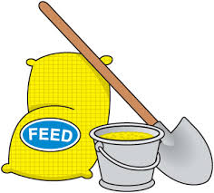Chickens eat chicken feed. The main ingredients are corn,

wheat, sorghum, or another grain. Vitamins and protein supplements, such as soybean meal, are added to their feed. **Broilers** eat one pound of feed each week. **Laying hens** eat four pounds of feed for every dozen eggs they lay. The types of supplements and the amount of feed

depend on the type of chicken the farmer is raising.

Today, Americans eat more than 100 pounds of chicken per person per year! In 1960, it was less than 30 pounds. Chicken is a delicious, low-fat source of protein for healthy diets. How do you like to eat your chicken?

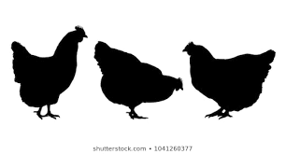

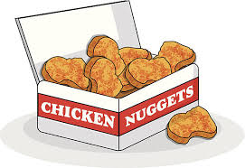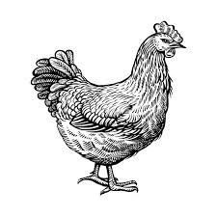

**How Well Did You Read?**

1. Chickens raised for their meat are called
   * broilers or laying hens.
   * roosters or fryers.
   * broilers or fryers.
   * roosters or laying hens.

2. Male chickens

* are called layers.
* are called roosters.
* are called hens.

3. The color of an eggshell is a result of

* where the egg is laid.
* the breed of hen laying the egg.
* the diet of the hen.
* the time of the year the egg is laid.

4. According to the article, which chicken eats more feed per week?

* rooster
* layer
* broiler
* baby chick

5. **How many more** pounds of chicken does the

average American eat now as compared to the

amount eaten in 1960?

* 70 pounds
* 30 pounds
* 50 pounds
* 40 pounds

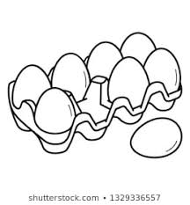

**The Bouncing Egg**

**Materials:**

* one hard cooked egg
* white vinegar
* clear container or jar with a lid

**Directions:**

1. Without breaking the shell, examine the hard-cooked egg carefully.

Record your observations.

1. Place the egg in the container. Cover it with the vinegar.

Place the lid on the container.

1. Predict what will happen in one hour, one day and one week.

Record your predictions.

1. Observe the egg at the designated times. Record your observations.
2. At the end of one week, rinse and dry the egg. Drop into a large bowl.

What happens?

1. What amazed you most as you did this experiment?

|  |  |  |
| --- | --- | --- |
|  | **Predictions** | **Observations** |
| one hour |  |  |
| one day |  |  |
| one week |  |  |

Egg Trivia

* The largest chicken egg ever laid had a double yolk and a double shell and weighed one pound.
* The average person eats 240 eggs each year.
* If you drop an egg, sprinkle it with salt for easier cleanup.
* You can tell if an egg in the shell

has been cooked by spinning it! Raw eggs wobble as the

liquid inside shifts, but

hardboiled eggs spin

smoothly.

Joke Time

1. Why did they let the chicken join the band?
2. How do chickens wake

up in the morning?



**Joke Answer:**

* On the average, one hen will lay 250 eggs per year.
* 99.1 billion chicken eggs were laid in the US in 2019.
* A hen requires

24 to 26 hours to

make an egg.

Thirty minutes later

the cycle starts over

again.

1. She had the drumsticks.

2. With an alarm cluck

Did You Know…?

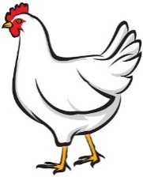

For more agricultural education lessons and resources, visit: **www.maefonline.com**