Soybean Trivia

* There are over 2,500 varieties of soybeans that come in many sizes, shapes, and colors.
* Soybeans grow on bushy plants that are about 2 ½ feet tall.
* Each soybean plant grows 60-80 hairy pods.
* A bushel of soybeans

weighs 60 pounds.

Joke Time

How many soybeans

can you put in

an empty bag?



* Soybeans are an excellent source of fiber. Fiber helps to keep our digestive system healthy.
* Soybean lecithin is used in the production of Hershey’s chocolate.
* Henry Ford grew soybeans to make enamel paint for his cars. This paint is still used today.
* Prang made the world’s

largest soybean crayon.

It weighed 330 pounds

and was 10 feet long.

Did You Know …?

**Joke Answer:**

One. Once you add one bean, the bag is

no longer empty.



For more agricultural education lessons and resources, visit: **www.maefonline.com**



[This Photo](https://en.wikipedia.org/wiki/File:Gnome-applications-science.svg) by Unknown Author is licensed under [CC BY-SA](https://creativecommons.org/licenses/by-sa/3.0/)



Links to Agriculture

**The Sustainable Soybean**

Soybeans are produced for human food, surprising everyday products, and livestock feed. Soybeans are one of the nation’s most fascinating and **versatile** edible plants. From foods to ink, paints to plastics, soybeans have hundreds of everyday uses. Some of those products are probably in your kitchen or garage right now.

Even though soybeans have been a major food crop in China for over 1,500 years, soybeans were not grown in our country until the 1800’s. At first soybeans were small, and their uses few, until a scientist named **George Washington Carver** began to find more and more uses for them. By 1904, he developed over 300 useful by-products from soybeans.

Soybeans touch our lives hundreds of times a day: when we eat, read a newspaper, get into our cars, and even when we open our front doors. Some of the products made from soybeans include: cereal, cooking oil, chocolate, hot dogs, candy, baby food, flour, soup, ice cream, vitamins, cookies, printing inks, soap, shampoo, fabric softener, paints, plastics, cosmetics, and pet food.

Some other uses for soybeans that scientists have discovered are biodiesel fuel, soybean crayons, soy ink, and building materials.



***Biodiesel Fuel*** ~ Biodiesel fuel, which can be used in any diesel engine, is made from soybean oil. The fuel is a clean-burning and biodegradable fuel that can help cities meet federal clean air standards. Unlike petroleum diesel, biodiesel fuel emits a much lower amount of pollutants, is sulfur free, and does not produce explosive vapors. Biodiesel fuel also provides similar horsepower, torque, and miles per gallon as petroleum diesel.

***Soybean Crayons*** ~ Soybean crayons are made with soybean oil instead of petroleum-based paraffin wax. Soybean crayons provide brighter and smoother colors that do not flake. These crayons can be found under the Prang Fun Pro™ Crayons name at many stores.

***Soy Ink*** ~ Soy ink is also made with soybean oil. Newspapers, commercial printers, and government agencies use soy ink instead of petroleum-based ink, because it prints more paper per pound and offers better color reproduction. It is also non-toxic, so it provides a safer environment for employees. Over 90 percent of all U.S. daily newspapers are printed using soy ink.

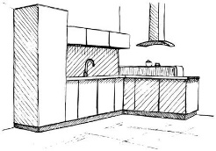***Building Materials***~ A bio composite building material is made with soy flour and recycled newspaper. A fourth-grade student from Minnesota contributed to inventing this new building material. Scientists continued research and development until they produced a board like wood, harder than oak, and lighter than granite. Bio composite building material can be used in countertops, furniture, plaques, and much more.

From Kids, Crops, & Critters, Illinois Farm Bureau



**Yummy**

**Soybean Pancakes**

(Get adult supervision before cooking!)

**Ingredients:**

1 ½ cups all-purpose flour ½ cup quick cooking oatmeal

2 Tablespoons Baking Powder 1 ½ cups soymilk

2 Tablespoons soybean oil 2 Tablespoons brown sugar

2 large eggs 1 cup fresh blueberries

Combine flour, oatmeal, sugar and baking powder in a bowl. Add eggs, milk and oil to dry ingredients mix until blended. Add the blueberries.   
With an adulting helping you, heat a skillet over medium heat, brush with soybean oil. Pour about 1/4 cup of batter on skillet, cook until bubbles begin to burst all over surface. Turn and continue to cook for one to two minutes. Repeat with remaining batter. Serve with butter and maple syrup.

In addition to soybeans, what other farm products are included in the recipe?

**How Well Did You Read?**

1. The author describes soybeans as **versatile**. Versatile means that something can be used in many ways. Name three uses for soybeans.

__________________ __________________ __________________

1. What scientist discovered more than 300 uses for soybeans?

______________________________________________________

1. Why is biodiesel fuel made from soybeans better for the environment than petroleum-based fuel?

______________________________________________________

______________________________________________________

1. What is another petroleum-based product that can also be made using soybeans?

______________________________________________________

1. What uses for soybeans surprised you the most. Why?

______________________________________________________

______________________________________________________

______________________________________________________

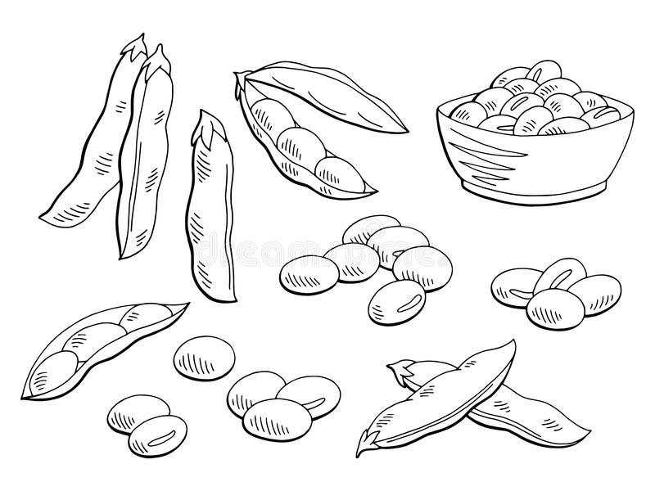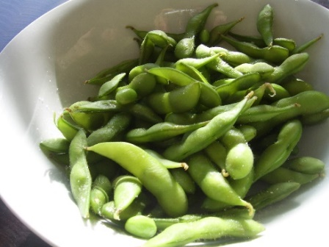

**Have you ever eaten these?**

These are “**edamame**” (ed-uh-‘mah-may), or **immature soybeans**. They are native to East Asia and were introduced to Japan by China in the 8th century. The Japanese then used soybeans to develop soy sauce. Now, both **edamame** and soy sauce are enjoyed by people all over the world!