Did you Know?

**There are bodies of water that are so dense, it is impossible to sink.**

The **Great Salt Lake in Utah** contains up to 30% salt in some areas, compared to about 3% in the oceans. This is because it was formed in an area where there is a salt concentration in the ground, and the lake has no outlet to the ocean.

Freshwater from mountain streams and rivers and rainfall add water to the lake, but the main way water leaves is through evaporation. Because of its high salt content, few species live within the lake itself, but brine shrimp, algae, plankton, and flies provide food to many birds that visit the area.

If you’ve ever been swimming in the ocean, you could probably feel the salt, or even taste it. In the Great Salt Lake, however, swimmers report that their skin feels like it is being rubbed with sandpaper! And don’t even think about trying to swim there if you have any scrapes or cuts!

The Great Salt Lake is only one of many salt lakes in the world. The Don Juan Pond in Antarctica is more than 40% salt, and never freezes, even in -50˚ C temperatures! The Dead Sea in Israel got its name because it is so salty that nothing can live in it!

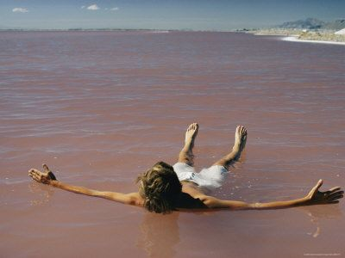

Joke Time

WW

What did the helium balloon say to the room air balloon?



**Joke Answer:**

Hello down there!

For more agricultural education lessons and resources, visit: **www.maefonline.com**

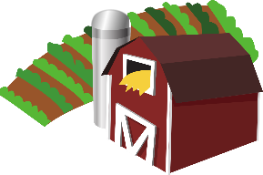

[This Photo](https://en.wikipedia.org/wiki/File:Gnome-applications-science.svg) by Unknown Author is licensed under [CC BY-SA](https://creativecommons.org/licenses/by-sa/3.0/)

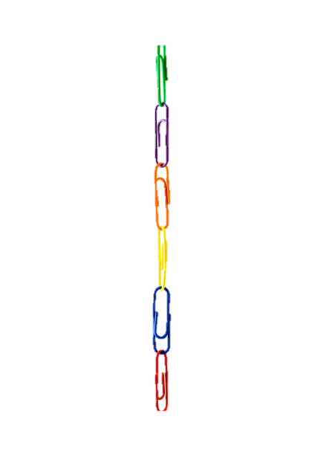

Links to Agriculture

**Saltwater Intrusion**

Think about a time when you had too much popcorn or chips…were you really thirsty after that? That’s because you needed more water to regulate the amount of salt in your body.

The Chesapeake Bay works kind of the same way. It is an **estuary**, a place where fresh water and saltwater come together to make **brackish** water. There are many different species of plants and animals that thrive within each different habitat. But, just like when you eat too much popcorn and drink a glass of water, the Bay’s **salinity**levels can go up and down.

Fresh water comes into the Bay from streams and rivers. Saltwater comes in from the ocean. Sometimes, though, there is a storm surge that washes up into the Bay, or a heavy rainfall that comes down the rivers. Because salt is denser than water, some salt sinks down and gets absorbed by the soil. When this happens, the plants and animals that live in that area become stressed and may not survive the changes in water quality.

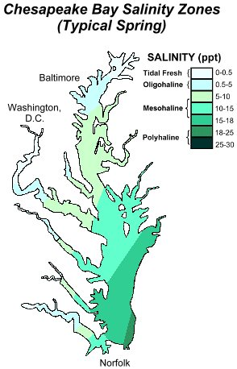

This is not only a problem for the plants & animals in the Bay itself, but for many farmers whose crops rely on the proper level of salt and other minerals in the soil to grow. This process, called **saltwater** **intrusion**,causes long term changes to the quality of water and soil.

Fresh water

Farmers can adjust these levels by adding **buffer zones**, planting more salt-tolerant plants. They can dig **irrigation ditches** to help prevent too much salt water from entering their fields or use soil additives to help control salinity levels. Unfortunately, though, farmland is being lost as ocean levels continue to rise.

Ocean – salt water

Bay – brackish water

Information from this article was adapted from “Saltwater Intrusion: A Growing Threat to Coastal Agriculture” from USDA Northeast Climate Hub. Climatehubs.usda.gov

**Have you ever wondered why a helium balloon floats up into the sky?**

It’s all because of the scientific concept of density. Density is a measure of how much stuff (mass) is filling up a space (volume).

Notice how the balloon on the left, filled with regular room air has more stuff in the same space? We say that balloon is ***more dense*** than the one on the right. When a substance is ***less dense*** than the substance surrounding it, it will float above it. Since the regular air in the first balloon is the same density as the air outside of the balloon, the balloon will not float.

Now, try out a similar experiment below using water, not air!

**To Float**

or **Not To Float?**



**Room Air**

**Helium**

**Bath Time Science!**

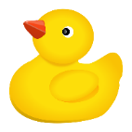

**Try this out next time you are in the bath…or the swimming pool!**

1. Choose several items to test: a ball, a toy car, an action figure, a rock, etc.
2. Think about whether you think the item will float (F) in the water or sink (S).
3. Make sure to write each item and your prediction before you try it!

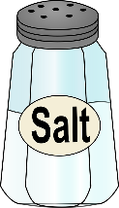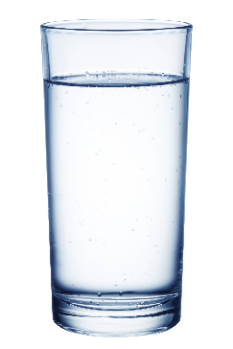

|  |  |  |  |
| --- | --- | --- | --- |
| **Item** | **Prediction (F/S)** | **Result**  **(F/S)** | **More or Less Dense than Water?\*** |
| 1. |  |  |  |
| 2. |  |  |  |
| 3. |  |  |  |
| 4. |  |  |  |

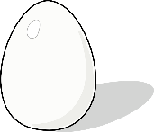**Question**: Which of your results were surprising to you?

**

*Remember! Just like with the Helium balloon, if something is less dense than the air or water surrounding it, it will float. If it is more dense, it will sink.*

**How Dense is Your Egg?**

**Materials:**

* 2 clear cups or glasses
* Water
* Spoon
* Salt
* 2 eggs

1. **Predict**: Is an egg more or less dense than water?
2. Fill the glasses half full with water. In one glass, add 2 tablespoons of salt and stir until it dissolves.
3. Carefully put an egg into the water in each glass.
4. **Reflect**:
   1. *What do you observe?*

______________________________________________________________

______________________________________________________________

______________________________________________________________

* 1. *Can you explain what is happening?*

______________________________________________________________

______________________________________________________________

______________________________________________________________



!