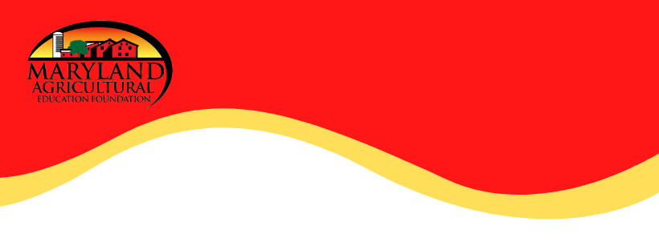
Farm to Table
Online Activity

Engage:

Right This Very Minute is a table-to-farm book that explains how farmers are always busy producing the food that makes its way to our plates! There are many farms, restaurants, and markets in Maryland that serve local produce right to our tables! If you are interested in learning more about farm to table businesses in Maryland, please click here!
Materials:
- Computer, tablet, or Ipad
- Video
- Research Articles

Remember, buying local produce helps Maryland's economy and support's our neighbors, friends, and family! So shop smart and shop local!

For a closer look at the life of a farm family, please check out FFA Maryland State President, Jill Allen's farm tour!

​ For more activities visit: www.maefonline.com

Explore:

Take a look at the following learning activities to get you started on your farm-to-table journey!

Learning Activities:

- K-1 Science – Food Sources
- 2-3 Science – Food Sources
- 2-3 Science – Food Sources Answer Key
- K-1 ELA – Main Idea & Details
- 2-3 ELA – Main Idea & Details
- K-1 Writing – Story Response Writing
- 2-3 Writing – Story Response Writing
- K-1 Math – Counting & Drawing
- 2-3 Math – Word Problems

Explain:

After your research, can you explain the following questions:

- Who are the people who grow food for us?
- What kind of vegetables might they grow?
- Why is it important to buy from local sources?

Extend:

Create your own peanut and jelly sandwich challenge!

Design article: https://www.youtube.com/watch?v=Ct-lOOUqmyY

