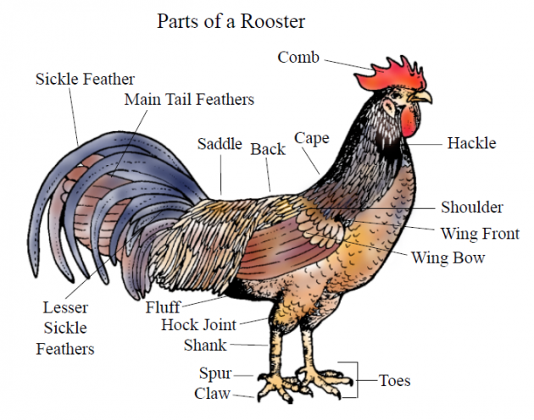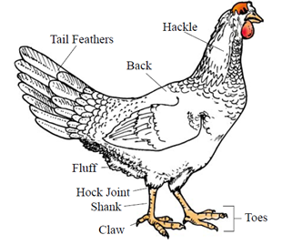

1. Which is larger?
2. Which has a larger comb?
3. Which is a chicken?
4. Which lays eggs?
5. Which has a beak?
6. Which has a saddle?
7. Which has more colorful feathers?
8. Which has claws on its toes?

A male chicken is called a rooster. A female is chicken is called a hen. A hen lays eggs, whereas a rooster does not.

Below are some images that display the anatomy of both a rooster and a hen.

* Answer **rooster**, **hen**, or **both** to the questions that follow.
* Write a paragraph that compares and contrasts the two. Draw on any information that you have read and may see in the images below.

**Chicken Anatomy**

This activity is adapted from: extension.org

This activity is adapted from: extension.org

This activity is adapted from: extension.org