Ag Literacy Program 2016
Learning about Chickens
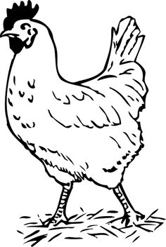
Web what you know about chickens.

- True or False Roosters and hens are both chickens.
- True or False A chicken lays an egg once a week.
- True or False White eggs are better for you than brown eggs.
- True or False The flap of skin on a chicken’s head is called a wattle.

- True or False Chicken feathers are either white or brown.
- What is one thing you want to know about chickens?

Learning about Chickens
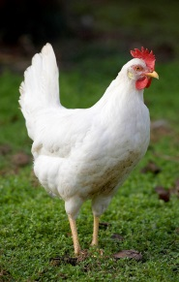
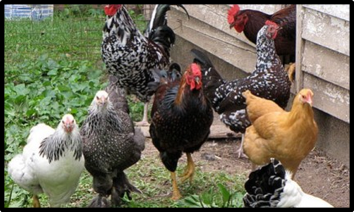
Chickens provide us with eggs and meat. Chickens raised for their eggs are called layers. Chickens raised for their meat are called broilers or meat chickens. Broiler chickens raised by farmers usually have white feathers.
A male chicken is called a rooster. A female chicken is called a hen. Roosters are larger than hens and have brightly colored feathers to attract females. The floppy skin on top of the chicken’s head is called a comb. The flap of skin that hangs from the chin of the chicken is called a wattle.
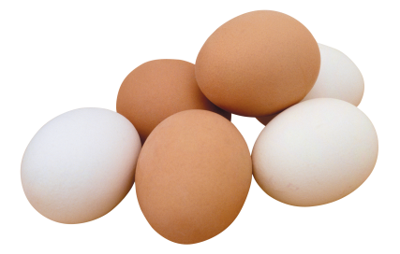
Some layers lay white eggs and some layers lay brown eggs. Both white and brown eggs have the same nutritional value. The color of the eggs depends on the breed of chicken.
A laying hen takes 24-26 hours to produce an egg. As a laying hen grows older her eggs increase in size. Layers can lay as many as 300 eggs in one year.
Farmers that raise chickens in chicken houses are able to protect them from predators. In the chicken house, chickens are fed a meal of ground corn and soybeans as well as vitamins and minerals. Farmers can keep the chickens warm in winter and cool in the summer.
Both broilers and layers provide us with many good things to eat. Can you name some?
- What is the difference between a broiler and layer?
Name
Learning about Chickens
- What is the difference between a rooster and a hen?
- Looking at the article, what do you think the word nutritional means by how it is used in the sentence?

- Compare how long you thought it took a chicken to lay an egg to how long it really takes.

- Compare how many eggs you thought a layer hen produces in one year to how many eggs a layer hen does produce in a year.

- What do you think some predators of chickens might be?
- Name at least three foods that need eggs as an ingredient.
- List at least three different ways people eat broiler meat.
- What did you learn about chickens that you didn’t know before?

