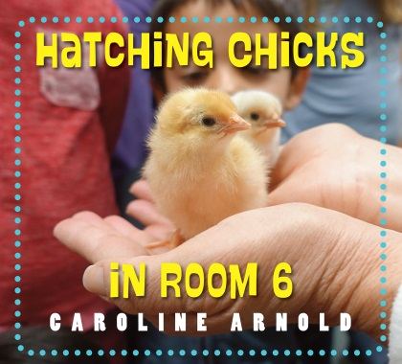
Hatching Chicks in Room 6 by Caroline Arnold

4. Parts of an Egg

Overview

Although many students may have seen or cracked open and egg, very few have examined it for the parts it contains. This activity provides lots of information regarding both the parts of an egg and their function. This lesson goes well with the one about the freshness of an egg.

Materials
- Paper or plastic small plate for each group of 3-5 students
- An egg for each group
- Egg Model worksheet

Procedure
- Pass out a plate and egg to each group.
- Have students describe what the outside of the egg looks like (white, smooth, bumpy).
- Have students describe what they think the inside of the egg will look like.
- Have adult crack open an egg for each group.
- Pass out the Parts of an Egg worksheet and let students examine the eggs close up and match the parts to the egg diagram.
- Assist students in identifying each of the following parts: shell, membrane, air sack, albumen, yolk, chalaza.
- First examine the shell and look for the membrane and air cell inside the shell. The smaller the air cell, the fresher the egg.
- Next look for the clear white part called the albumen.
- Check out the height of the yolk. The higher the yolk the newer the egg; the flatter the yolk the older the egg.
- Look for the stringy white pieces on either side of the yolk called the chalaza which holds the yolk in place.

yolk | albumen | shell
chalaza | air sack | cell membrane

2.
1.

www.maefonline.com
3.
4.
6.
5.

