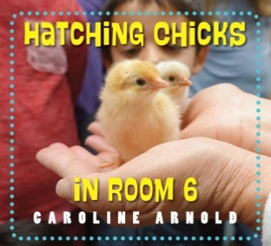
Hatching Chicks in Room 6 by Caroline Arnold

2. Acting out the Incubation Process

The following activity with the class will help to review what happens to eggs that hatch and become chicks.
Divide the class into four main groups:
- Incubators – hold hands to form round incubator
- Eggs
- Calendar Counters – with calendar
- Caretakers with signs food, warmth, water
- Brood box – hold hands to form a rectangular or square brood box

The eggs can be placed inside the hand-holding incubator group to be warmed. The caretakers can use a calendar and pretend to count off the 21 days needed for the eggs to hatch. When the special time comes, the eggs can begin to peck at their eggshells and pretend to be newborn chicks. Once the chicks have hatched, the caretakers will need to take them to the brood house. After the caretakers have counted off a couple of days, they and the former incubators can gently pet and handle the growing, fluffy chirping chicks. Caretakers should wear signs that say – Warmth, Food, and Water.

Acting out the Incubation Process

1.
Five to six students stand in a circle holding hands to form an incubator.
Three to four students stand inside the incubator and are the fertilized eggs.

2.
One or two students
use a calendar to count off 21 days.

3.
When 21 days are up, the chicks
begin to peck at their shells making a pipping sound. Hatching is hard work and the baby chicks lie down and rest while their feathers dry.

4.
The next day, the chicks are peeping. Their feathers are dry and they are hopping around the incubator. Their fluffy feathers are called down and keep the chicks warm.

Caretakers wearing signs that say Warmth, Food, and Water help move peeping chicks from the incubator to the Brood Box. When they are not eating or drinking, they snuggle together.
v
5.
Brood Box

6. After 6 days, the students that formed the incubator can now come over with the caretakers and hold/pet the chicks.
www.maefonline.com

Signs for Acting out the Incubation Process
Warmth
Water
Food

