Links to Agriculture

**Glorious Gardening**

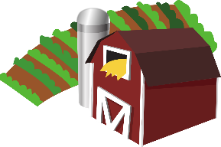

[This Photo](https://en.wikipedia.org/wiki/File:Gnome-applications-science.svg) by Unknown Author is licensed under [CC BY-SA](https://creativecommons.org/licenses/by-sa/3.0/)



**What is a farmer?**

A farmer is someone who grows food to feed people. If you grow food at your house, you are a farmer!

**How did gardening change in 2020?**

In 2020, a new coronavirus hit the United States and the rest of the world and made getting food a challenge! Many people decided to grow their own food. In a normal year, 35% of households in the US grow food at home or in a community garden. In the spring of 2020, many garden centers sold out of seed packets and plants because more people were turning to home gardening to feed their families.

**Why do people garden?**

People garden at home for many different reasons. They like the convenience of “shopping” in their back yards. The taste of vegetables fresh from the plant is a special treat. Choosing only to plant those vegetables that the family will eat is a good choice. Having extra vegetables to share with neighbors and family creates an atmosphere of community.

Extra vegetables may also be sold to create additional income for the family. In addition, those extra vegetables can be preserved, canned or frozen for use in the fall and winter. Gardening at home encourages people to experiment with new varieties of old favorites or to try a totally new vegetable. Families may also try new ways of cooking the vegetables. Spending time outside with others who also enjoy gardening is another plus of the home garden.

**Do you want to start a garden?**

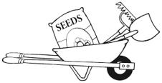Gardening takes planning and tools. A garden center will have a lot of helpful information. Look around in your community. There may be people that garden and are willing to help your family start your own backyard “farm”.

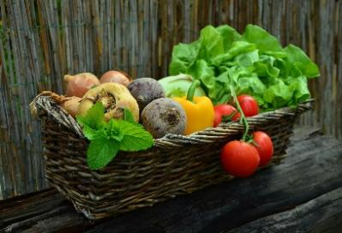

**How Well Did You Read?**

1. State three reasons why people like to grow their own vegetables.

__________________________________________________________

__________________________________________________________

1. How did the new coronavirus in 2020 affect gardening in the United States?

__________________________________________________________

__________________________________________________________

1. What is something you can learn from growing your own garden?

__________________________________________________________

__________________________________________________________

1. Name a resource that can help you get started on your backyard garden

__________________________________________________________

__________________________________________________________

1. List your three favorite vegetables.

____________________________________

____________________________________

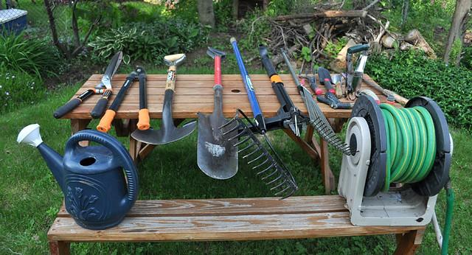

**Gardening Supplies Scavenger Hunt**

**An activity for the whole family!**

As with most new activities, certain equipment is needed.

An adult would need to gather the tools and hide them around

the yard. Each “gardener” should be given a list of the tools that

need to be found. Set a time limit and have fun! The more involved the

youngsters are in the start of the garden, the more likely they will continue

with the fun throughout the growing season.

**Basic Supplies**

Calendar, notebook/journal, pencil

Hat, sunscreen, sunglasses

Garden Rake Hoe Small Trowel

Tape Measure Watering Can Plastic Buckets

Seed Packets Plants Shovels for digging

Why can’t you tell secrets

by the corn field?

Joke Time

**Joke Answer:**

Because the corn

has ears.

**Garden Trivia**

1. Tomatoes are the most popular vegetable grown by the home gardener.
2. Cucumbers, sweet peppers, green beans, squash and onions are all popular vegetables grown at home.
3. Everyone should eat a “rainbow” of vegetables every day.
4. Potatoes are grown from the “eyes” of old potatoes.
5. Popcorn is easily grown in the home garden.

**Did You Know?**

1. A fruit is the part of a plant that develops from a flower and produces seeds.

1. Many plant parts we eat and call vegetables are really “fruits”.

1. A true vegetable is the food product that comes from any part of the plant other than the flower.

For more agricultural education lessons and resources, visit: **www.maefonline.com**