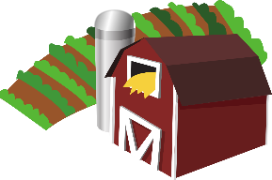
Links to Agriculture
Does Pizza Grow on a Farm?
This Photo by Unknown Author is licensed under CC BY-SA

When asked where you get your pizza, many students think of a pizza delivery store. However, if you trace all of the ingredients in your pizza
back to where they originate, you will discover they all come from a farm. Many different kinds of farmers are needed to produce the ingredients
for your pizza.
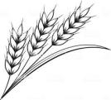
- A wheat farmer raises the wheat that will be turned into flour for the crust.

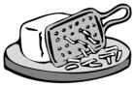
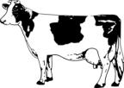
- A dairy farmer raises the cows that will produce milk to make the cheese.

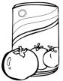
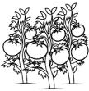
- A fruit and vegetable farmer raises the tomatoes that will be used to make the sauce.

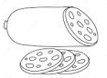
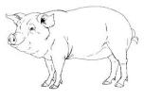
- A pig farmer raises the pigs that will be used to make the sausage and pepperoni for your pizza.

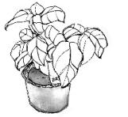
- An herb farmer grows the herbs that season the pizza like oregano and basil. Sometimes these herbs are added fresh and sometimes they’re dried first and sprinkled on.

How Well Did You Read?
Choose the best way to complete the sentence.

- Flour is used to make the pizza __________.
  - sauce
  - crust
  - cheese

- A __________ farmer raises cows.
- pig
- wheat
- dairy

- Tomatoes are used to make the pizza __________.
- sauce
- cheese
- pepperoni

- What are your favorite pizza toppings? Tell what kind of farmer raises your toppings.
_____________________________________________
_____________________________________________
_____________________________________________

Make Your Own Pizza

Ingredients:
- English Muffins
- Shredded Cheese
- Tomato Sauce
- Your Favorite Toppings (Pepperoni, Peppers, Bacon)

Directions
- Separate your English muffin into 2 sections.
- Cover each section with sauce.
- Sprinkle cheese over the sauce.
- Add your toppings.
- Place on a pizza tray.
- Have an adult put it in the oven.
- Bake at 425 degrees for 5-10 minutes.

Yeast on the Rise
Try this experiment to watch yeast at work.

Yeast is an important ingredient that is added to pizza dough and bread to make it rise. Yeast is a live organism that forms bubbles and air pockets to make the crust light and tasty.
If you carefully look at pizza crust or bread, you can see the air pockets produced by the yeast. Yeast works best under certain conditions. Set up the following situations and see what you discover.

Label four clear glasses or cups #1, #2, #3 and #4. To each glass add the following:

#1 – One teaspoon of yeast and ¼ cup cool water
#2 – One teaspoon of yeast and ¼ cup warm (not hot) water
#3 – One teaspoon of yeast, ¼ cup warm water, and one teaspoon of sugar
#4 – One teaspoon of yeast, ¼ cup cool water, and one teaspoon of salt

Watch the glasses carefully over the next 30 minutes.
- Describe what happens in each of the glasses.
- In which glass do you notice the most action?
- What condition produced the most action?
- How does the action of the yeast help you understand the holes in pizza or bread?

Pizza Trivia
- About 3 billion pizzas are sold each year in the U.S.

- The first Pizza Hut restaurant opened in Wichita, Kansas in 1958.

- October is National Pizza
Month in the U.S.

- Eggs are a popular pizza
topping in Australia, and
squid is popular in Japan.

Joke Time

- Why do people get into the pizza business?

- Why are jokes about pizza not funny?

- Kansas is the largest wheat producer in the United States, with North Dakota second.

- The United States is the top producer of cheese in the world, with Wisconsin and California leading the states in production.

- Eating tomatoes will give you healthy eyes and skin since they contain vitamins A and C.

- Pepperoni is the
favorite pizza topping
in the U.S. It is on 36%
of all pizzas ordered.

Joke Answer:

Did You Know…?

- Because they knead some dough
- Because they are too cheesy

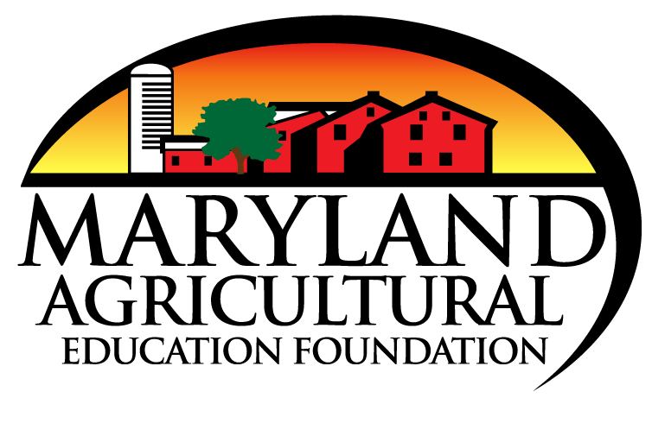
For more agricultural education lessons and resources, visit: www.maefonline.com

