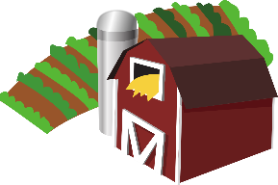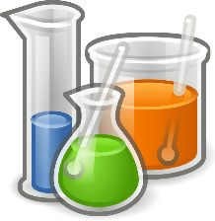

[This Photo](https://en.wikipedia.org/wiki/File:Gnome-applications-science.svg) by Unknown Author is licensed under [CC BY-SA](https://creativecommons.org/licenses/by-sa/3.0/)



Links to Agriculture

**Cleaning Up Our Water**

Water is a ***natural resource*** that is essential to all life on Earth. Water is in most of the things that we eat and drink every day. Your body is about 65% water and believe it or no A person can live about a month without food, but only about a week without water.

Water covers about 70% of the Earth’s surface, but the amount that is available for us to use is actually very small. Imagine a gallon jug filled with water to represent all the water in the world. Only about one tablespoon of that water would be useful to us. The rest is in oceans, glaciers, and the atmosphere. Out of that one tablespoon, we need to have water for drinking, cooking, cleaning, bathing, and farming. We use about 27 trillion gallons of groundwater every year just in the United States alone. Of that amount, about 80% is used for agriculture to grow and raise what becomes your food.

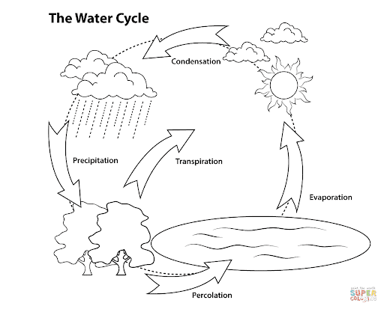

The Earth has its own system of cleaning and recycling water naturally through the processes of the ***water cycle.*** The sun heats the surface of the Earth, causing water to ***evaporate***. Eventually, the vapor cools off and ***condenses*** to form a cloud. Once the cloud becomes heavy enough, the water falls back to the surface as ***precipitation***, where some of it ***percolates*** through layers of soil and rock to become ***groundwater.***

Before we had modern plumbing, people would dig a well to use groundwater for their families, since the water had been thoroughly recycled. There are still many people in the world who rely on wells as their only source of clean water.

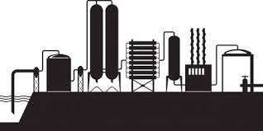***Water treatment plants*** are another way that we obtain clean water. Because of modern technology, we can turn on a faucet, and clean water comes out. All the water that goes down the drain in your sink, tub, or toilets goes through a series of underground tunnels to a treatment plant. At the treatment plant, the water is passed through filters to remove particles of waste. The water is tested and chemically treated to destroy any remaining bacteria.

Once the water passes inspection, it is pumped through pipes back into our neighborhoods, ready to use again. Farmers rely on this clean water as well to make sure that they are watering their crops and providing their animals with clean water to drink. Those animals and crops eventually become our food and it’s important to farmers that what they grow is good for us.

***Water conservation*** is the practice of using water efficiently to reduce unnecessary water usage. Water conservation is important because fresh clean water is a limited resource, as well as a costly one. If you do something as simple as turning off the faucet when you brush your teeth in the morning and at night, you could save up to 2 gallons of water per person each day. If everyone brushes their teeth twice a day, that is 16 gallons for a family of four! Small changes can make a big difference.

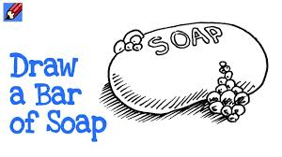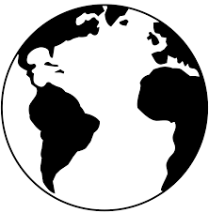

**How Well Did You Read?**

1. Explain why only a small amount of the water on Earth

can be used by people.

______________________________________________________

______________________________________________________

______________________________________________________

1. How does the Earth naturally clean and recycle water?

______________________________________________________

______________________________________________________

1. What is the purpose of a water treatment plant?

______________________________________________________

______________________________________________________

1. Why is water conservation important?

______________________________________________________

______________________________________________________

**Put a next to something you will do to conserve water inside.**

* Take shorter showers.
* Turn off water while soaping hands.
* Turn off water while brushing teeth.
* Only use the washing machine for full loads of laundry.

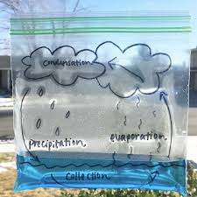

**Make your own**

**Water Cycle in a Bag!**

**You’ll need:**

* 1 ZipLock bag
* 1/2 cup tap water
* 1 drop food coloring (optional)
* Markers
* Tape

**Procedure:**

1. Use your markers to draw and label the water cycle on the front of the bag. You can add as many details as you like, but make sure to include the sun, clouds, and a water source.
2. Measure ½ cup of tap water and add a drop of food coloring if you want.
3. Carefully pour the water into your bag, and zip it tightly closed.
4. Find a sunny window and use tape to attach the top of the bag to the window. Tape along the zipper to make sure no water comes out of the bag.
5. Observe your water cycle over the next few days.
6. Can you observe evaporation, condensation, and precipitation in your bag?

**Put a**  **next to something you will do to conserve water outside.**

* Use a broom instead of a hose to clean sidewalks or driveways.
* Use a shut off nozzle on your hose.
* Plant flowers that don’t need a lot of water.
* Mulch around plants to hold water in the soil.

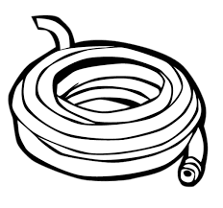

Water Trivia

* Every drop of water on our planet is the same water that has always been here. It goes through the **water cycle** again and again.
* Approximately 400 billion gallons of water are used in the United States every day.
* Water helps to regulate the Earth’s temperature.
* Fifteen percent of people in the United States rely on well water.
* A leaky faucet that drips water at the rate of one drip per second

can waste more than 3,000

gallons per year.

Joke Time

1. What did one ocean say to the other?
2. What letter is always wet?

W

did



**Joke Answer:**

1. Nothing.

It just waved!

1. C

Did You Know …?

Some people think that ***storm drains*** also carry water to a treatment plant. That is incorrect.

The only water that gets treated is the water from inside your home. Storm drains only carry rainwater, so it is important to never put waste down a storm drain! All the water from storm drains goes to streams and rivers that lead to the Chesapeake Bay.

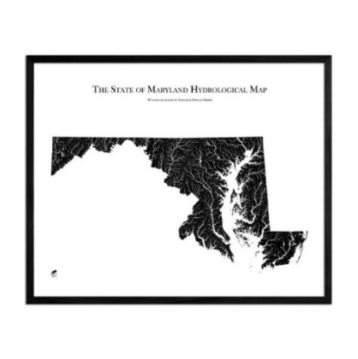

For more agricultural education lessons and resources, visit: **www.maefonline.com**