Wetland Trivia

- February 2nd is World Wetlands Day.

- Wetlands are found all over the world.

- The Florida Everglades wetlands cover more than 2 million acres.

- Some animals visit the wetlands as they travel from one area to another.

- Some animals spend
their whole lives
in the wetlands.

Joke Time

- Why are frogs so happy?

- Why do fish swim in schools?

Joke Answer:

- Wetlands help to clean the water that people drink.

- Wetlands provide a place for rainwater to go during storms. This helps to reduce flooding where people live.

- Wetlands can hold saltwater, freshwater, or a mix of both.

Did You Know…?

1. Because they eat whatever bugs them.
2. Because they can’t walk.

For more agricultural education lessons and resources, visit: www.maefonline.com

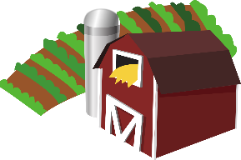
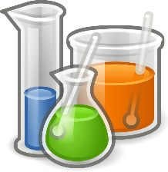
Links to Agriculture
Wetland Wonders
This Photo by Unknown Author is licensed under CC BY-SA

Areas where land and water mix together are called wetlands. Wetlands have shallow water or very wet soil most of the year. Wetland areas are often found along streams, lakes, and rivers. They can be large or small. Some stay wet all year and others have periods where they are dry. All wetlands provide a place for plants and animals to live.

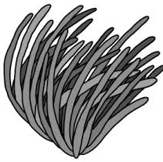
Seagrass and cattails are two plants that are often found growing in the wetlands. Duckweed is a floating plant that can cover large areas of the shallow water. Some wetland areas have shrubs and trees growing in the water.
seagrass

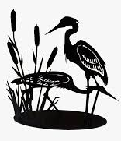
Seagrass provides a safe place for crabs, shrimp, and small fish to hide. Frogs and toads often lay their eggs near cattail plants. Turtles and snakes eat the insects that live in the wetlands. Birds such as ducks, geese, and herons build nests in the wetlands and eat the fish and plants. Otters and beavers also live in wetlands.
herons and cattails
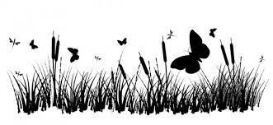
Wetlands are an important part of our environment. They provide a perfect place for many plants and animals to live.
How Well Did You Read?

Circle the plants and animals that live in the wetlands.
Put an X on the plants and animals that do not live in the wetlands.

crab | duckweed | cat
cattail | penguin | toad
turtle | beaver | fish
coconut palm tree | duck | heron

Where Are the Animals?

This wetland area has land, water, and plants.
Add some animals you might find in the wetlands.

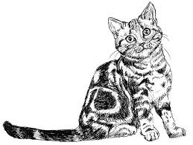
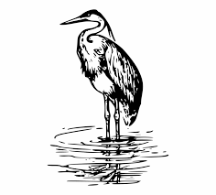
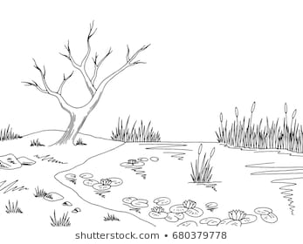
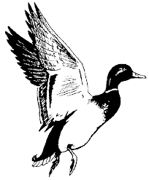
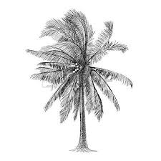
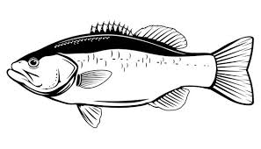
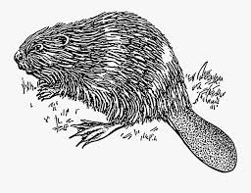
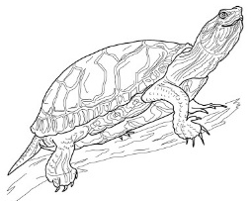
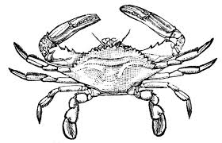
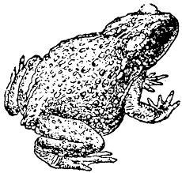
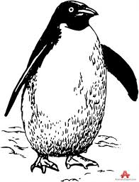
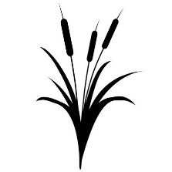
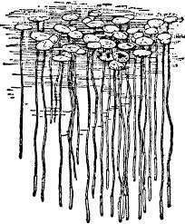

Areas where land and water mix together are called
_____ _____ _____ _____ _____ _____ _____ _____.

