Farm Trivia

* There are more than 12,000 farms in the state of Maryland.
* More than 350,000 people work on Maryland farms.
* Chickens are raised more than any other animal on Maryland farms.
* The crop grown most in Maryland is corn.
* There are over 2 million

farms in the United States.

Joke Time

1. Why did the farmer bury all of her money?
2. How did the farmer fix his jeans?

**There are many science careers associated with the natural environment. Consider some of these possibilities:**

***Environmental consultant* -** Work alongside farmers to find solutions to soil erosion and fertilizer run-off issues.

***Hydrologist*** – Help protect

our water supplies and

water quality.

***Botanist*** – Study plant life

and the effects of pollution on plant life or identify new plant species.

***Turf scientist*** – work to care for lawns, golf courses park sites, and athletic fields.

***Logging engineer*** – Design timber transportation and harvesting systems working with technical machines and computers.

Did You Know…?



**Joke Answer:**

1. To make her soil rich
2. With a cabbage patch



For more agricultural education lessons and resources, visit: **www.maefonline.com**

Links to Agriculture

**Farming Practices for the Environment**

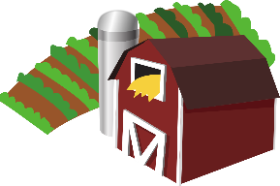

[This Photo](https://en.wikipedia.org/wiki/File:Gnome-applications-science.svg) by Unknown Author is licensed under [CC BY-SA](https://creativecommons.org/licenses/by-sa/3.0/)



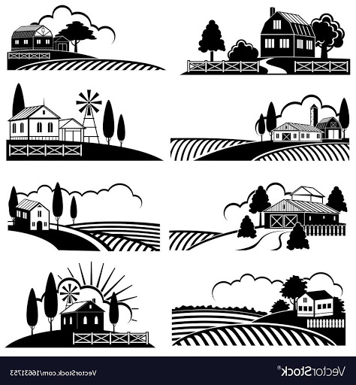Farmers are sometimes referred to as “**Stewards of the Land**.” This means they have a responsibility to take care of the farmland which produces the food we eat and fiber for our clothes. Farmers work hard to protect the environment we live in by **preventing or reducing pollution of our land and water.**

**Surface runoff** is water that flows over the land surface and ends up in our streams, rivers, and other bodies of water. Runoff can come from rain, snowmelt, or other sources. As runoff flows across the ground, it can pick up soil contaminants such as pesticides or fertilizer which can pollute our bodies of water. There are many methods that farmers use to keep our land and water healthy:

* 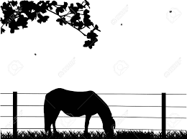Farmers fence their animals to keep waste away from water and to prevent erosion along stream banks.
* Farmers leave bufffer zones of trees and grasses along streams to help filter pollutants coming off of the land and to prevent erosion.
* Farmers leave behind stalks and leaves of harvested crops to protect the soil from erosion.
* 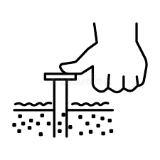Farmers plant cover crops after harvest to prevent erosion. These crops are plowed under in the spring which adds nutrients to the soil and reduces the amount of fertilizer needed.
* Farmers test their soil each year and only add fertilizer when necessary.
* Farmers use a variety of methods to remove harmful pests from crops and only use pesticides when other methods do not work.
* Farmers use structures to protect stockpiled manure until it is needed as fertilizer.

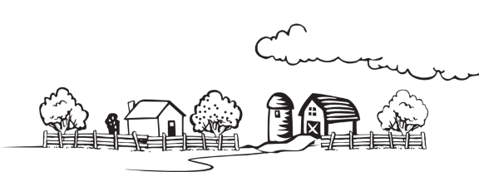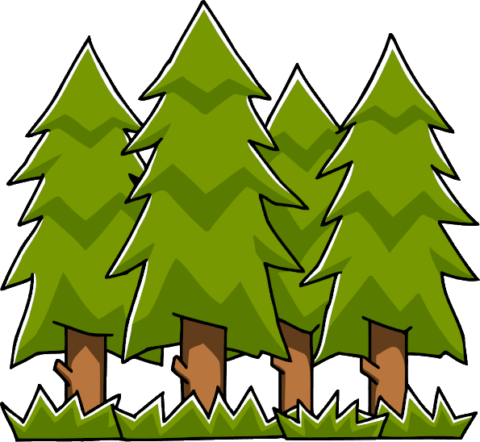

**What Can You Do?**

Farmers do their part to take care of the environment,

but what can **YOU** do to show you care? **Check** all the

things you **already do**. **Circle** one new thing you **can do**.

* Turn off the water while you are brushing your teeth.
* Turn off the TV and lights when you leave a room.
* Compost your food waste.
* Walk or bike when you can.
* Plant flowers and trees around your house to increase the amount of oxygen.
* Do not kill spiders because they eat other pests.
* Take small amounts of food to reduce waste. You can go back for more.
* Use rechargeable batteries.
* Pack your lunch with reusable containers and place in a reusable lunchbox.
* Recycle!
* Carry a refillable water bottle.
* Plant a garden.

**How Well Did You Read?**

1. Why are farmers sometimes called “Stewards of the Land?”

_____________________________________________________

_____________________________________________________

1. What is surface runoff?

_____________________________________________________

_____________________________________________________

1. How can surface runoff cause pollution?

_____________________________________________________

_____________________________________________________

1. What is one method farmers use to help stop soil erosion?

_____________________________________________________

_____________________________________________________

1. What is one method farmers use to reduce the amount of chemical fertilizer they add to the soil?

_____________________________________________________

_____________________________________________________

1. Give two examples of synthetic fabrics.

_____________________________________________________

1. List some of the advantages and disadvantages of synthetic fabrics.

________________________________________

________________________________________

________________________________________

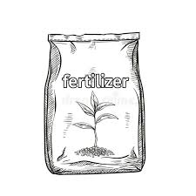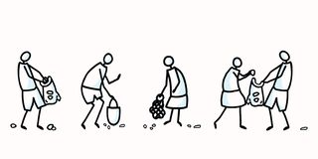

**Go Above and Beyond!**

Encourage friends and family to reduce their amount of waste and have them join in on helping to care for our environment!