Cow Trivia

* Cows can clean their noses with their tongues.
* The natural lifespan of a cow is about 25 years.
* It takes about 350 “squirts” to make a gallon of milk.
* A typical cow generates about 20,000 pounds of manure in a year.
* Cows don’t bite because they have no upper front teeth. Instead they have a thick, tough pad of skin on their top jaw. They curl their very large tongue around the food they eat.
* A Holstein's spots are like a fingerprint. No two cows have the same pattern of black spots on their white body.

Joke Time

1. Why does a milking stool have only three legs?
2. How does a farmer count a herd of cows?



* Dairy cows weigh about 1,400 pounds. That is equal to 28 children who weigh 50 pounds each!
* A cow gives almost 200,000 glasses of milk in her lifetime! That’s enough to fill the average classroom two feet deep with milk!
* Studies have shown that

classical music helps cows

produce more milk.

**Joke Answer:**

Did You Know…?

1. Because the cow has the udder

2. With a Cow-culator



For more agricultural education lessons and resources, visit: **www.maefonline.com**

Links to Agriculture

**Divine Dairy**

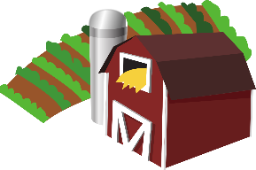

[This Photo](https://en.wikipedia.org/wiki/File:Gnome-applications-science.svg) by Unknown Author is licensed under [CC BY-SA](https://creativecommons.org/licenses/by-sa/3.0/)



**What Are Dairy Cows?**

Dairy cows are amazing animals. They can turn grass and

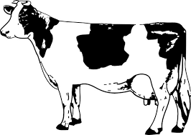grains into milk! ***Heifers*** are female dairy cattle and after two years, they usually give birth to their own calves. All female dairy cows must have a calf to produce milk. Newborn calves weigh about 80-100 pounds! They start standing up within a few minutes of being born. Male dairy cattle are called ***bulls*** and do not produce milk.

**What Do Dairy Cows Eat?**

Cows eat hay, **silage** and grain. Silage is fermented corn, wheat, or straw with the stalks and leaves. Cows eat 50 pounds of silage as well as 40 pounds of feed and hay each day, for a total of 90 pounds. Dairy cows also drink 25-50 gallons of water each day – that is nearly a bathtub full of water.

**Why Is Milk Good for You?**

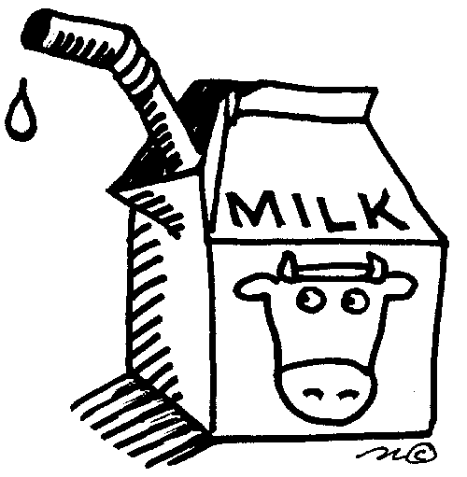Milk provides your body with calcium, which is needed for healthy

bones and teeth. Calcium helps our muscles and nerves work properly. Calcium also helps our blood to clot. Milk products also provide us with carbohydrates, protein, and Vitamin D. You should have three servings of nonfat or low-fat milk and milk products each day. One serving of dairy is equal to one cup of milk, yogurt, or ice cream, and one to two ounces of cheese. It isn’t hard to get your “3-A-DAY”.

**How Can You Stay Strong?**

Your bones need more than calcium to stay strong. They also need exercise! How many of these good bone-building activities do you like to do?

football - soccer - dancing - running - jumping rope - lacrosse

basketball - ice skating - biking - lacrosse – gymnastics – roller skating



**What Did You Learn?**

1. A female cow is called a _______________.
2. A male cow is called a _______________.
3. Write the main idea for the following puzzle:

*Corn + silage + grain + water = _______________*

1. Circle all of the body parts that the calcium in milk helps:

*bones teeth muscles blood nerves*

1. Write the main idea for the following puzzle:

*3-A-DAY + exercise = _______________*

1. Circle the 3 foods you would most like to eat to make up your 3-A-DAY.

*milk cheese yogurt ice cream*

**Curds and Whey – An Experiment**

**Ingredients:**

* 1 cup milk
* 1 tablespoon vinegar

**Procedures:**

1. Place one cup of milk in a bowl.
2. Add one tablespoon of vinegar.
3. Let it sit for one hour at room temperature.
4. Check the bowl periodically to see curds forming.

**Cheese** is made by adding a bacteria culture, called an enzyme, to milk. The enzyme causes the milk to curdle or form curds. The **curds** (solid parts) are separated from the **whey** (the watery liquid). If you look carefully, you will see the curds look very much like cottage cheese.

**Whey** is an **additive** in many foods such as breads, crackers and commercial pastry. It is also used in animal feeds. Next time you hear about Little Miss Muffet, you will know exactly what *curds and whey* really are!

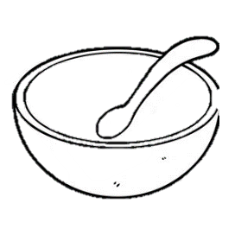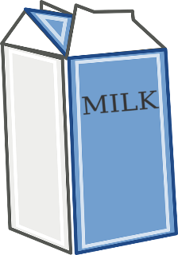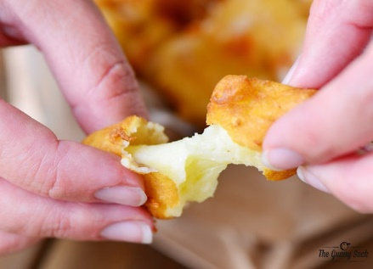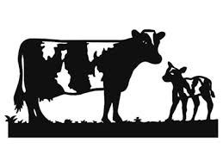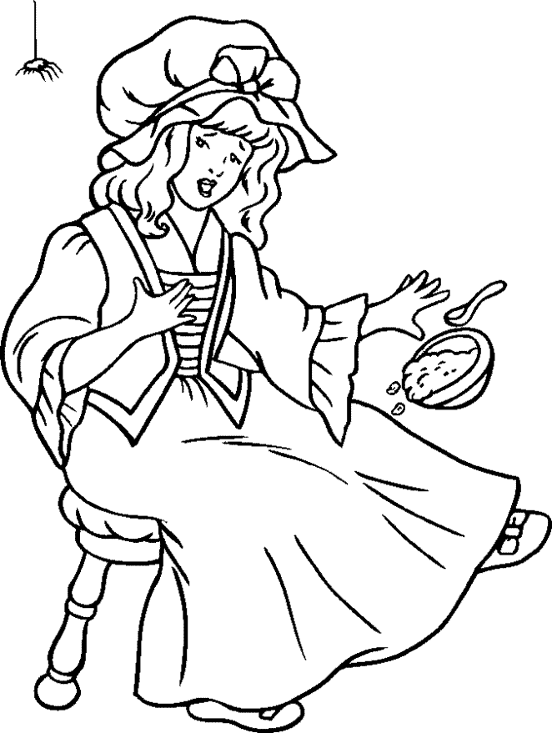

The Nursery Rhyme *Little Miss Muffet* was first published in 1805.

*Little Miss Muffet sat on her tuffet,*

*Eating her* ***curds*** *and* ***whey****.*

*Along came a spider and sat down beside her*

*And frightened Miss Muffet away!*

**What are curds and whey?**

**Have you ever eaten these?**

These are **fried cheese curds**. To make them, the curds are dipped in a batter and deep fried. In some states, this snack is sold at state and county fairs. Fried cheese curds are a favorite snack in Wisconsin and Minnesota.