Soybean Trivia

* Soybeans grow in pods like peas.
* Soybeans have been grown in Asia for centuries. They were first brought to North America in 1765.
* Many breads, cookies, crackers, pies, and cakes contain soybean oil.
* Soybean oil is also used to make machine oil, paint, candles, and beauty products.
* Soybean oil is used to make

an environmentally

friendly fuel for

diesel engines.

Joke Time

How many soybeans

can you put in

an empty bag?



* NASA selected the soybean crayon to

fly on the Space Shuttle Columbia in

1997. This crayon was truly out of this world!

* Prang made the world’s largest soybean crayon. It was a

whopper that weighed

330 pounds and was

10 feet long. It made

the Guinness Book

of World Records!

**Joke Answer:**

Did You Know …?

One. Once you add one bean, the bag is

no longer empty.

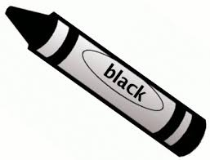

For more agricultural education lessons and resources, visit: **www.maefonline.com**

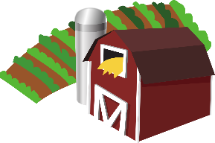

[This Photo](https://en.wikipedia.org/wiki/File:Gnome-applications-science.svg) by Unknown Author is licensed under [CC BY-SA](https://creativecommons.org/licenses/by-sa/3.0/)

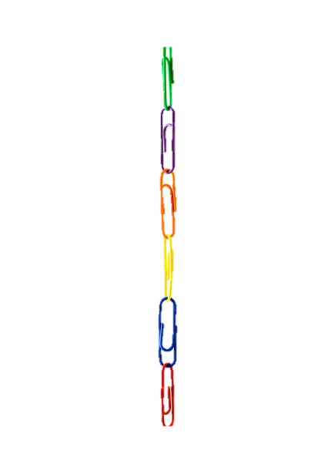

Links to Agriculture

**The Colorful Soybean**

In 1997, the first new crayon in nearly 100 years was produced by the Prang Company. The main difference between Prang crayons and regular crayons is the natural resource used to make them.

The basic natural resource used for making regular crayons has been petroleum oil. Petroleum for wax crayons comes from oil wells which are mostly located outside of the United States. It is a liquid created beneath the Earth’s surface over millions of years. It is made from large amounts of tiny dead plants and animals under high temperatures and pressure. Since humans cannot make petroleum, there is a limited supply of this **non-renewable resource**.

The basic natural resource used for making Prang crayons is soybean oil. Soybean oil comes from soybeans which are grown by American farmers. Farmers in at least 31 different states grow over 4 billion bushels of soybeans each year. America is one of the world’s largest producers of soybeans. Since soybeans can be replanted each year, they are a **renewable resource**.

In the production of Prang crayons, soybean oil provides 85% of the necessary ingredients. The soybean oil from one bushel of soybeans will make 2,112 crayons. One acre of soybeans can produce 82,368 crayons!

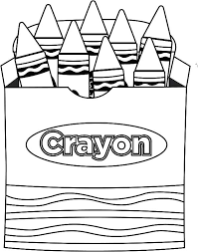So, how do soybean crayons compare to wax crayons? Wax crayons do not blend well since wax won’t color over wax. Since there is no wax in soybean crayons, blending is easy. In tests done by children aged 3-10 years old, Prang soybean crayons were preferred because they were smoother, brighter, and less flaky. Soybean crayons also cost slightly less than the leading brand of wax crayons. Try them out today and use something made from a renewable resource!

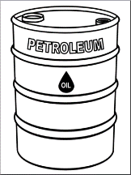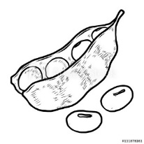

**Experiment with Color**

**Since Prang’s soybean crayons can easily be**

**blended, complete this experiment to see**

**what new colors can be created by “blending”**

**red, yellow, and blue!**

**Materials needed:**

* Red, yellow, and blue food coloring
* Very warm water
* Cold water
* Clear plastic cups (6-8)
* Ice cube trays

**Steps**

1. Use the food coloring and cold water to make red, yellow, and blue ice

cubes.

2. Fill the plastic cups about halfway with very warm water.

3. Put two different colored ice cubes in one cup of warm water. What

new color is formed? Fill in the chart below.

4. Continue making new colors. Can you predict what color the two cubes will make?

5. What happens if you add a third color to the cup? What color do you get?

red + blue = _________________

_________________ + _________________= _________________

_________________ + _________________= _________________

____________ + ____________ + ____________ = ____________

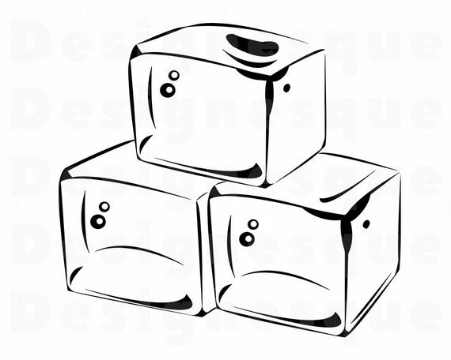

**What Did You Learn?**

1. Fill in the chart below with information from the article you read.

|  |  |  |
| --- | --- | --- |
| **Crayon Characteristics** | **Wax Crayons** | **Soybean Crayons** |
| Natural resource used |  |  |
| Renewable or  non-renewable |  |  |
| Cost |  |  |
| Brightness |  |  |
| Flakiness |  |  |
| Ability to blend |  |  |

1. Which of the things you read about the soybean crayon do you

find most interesting?

__________________________________________________________

__________________________________________________________

1. Why would a crayon made from soybean oil be a better choice

for our environment than a crayon made from petroleum oil?

__________________________________________________________

__________________________________________________________