Links to Agriculture

**All About Sheep**

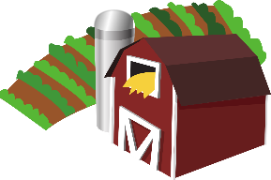

[This Photo](https://en.wikipedia.org/wiki/File:Gnome-applications-science.svg) by Unknown Author is licensed under [CC BY-SA](https://creativecommons.org/licenses/by-sa/3.0/)



**Names for Sheep**

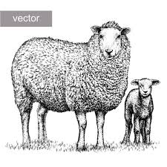

Just like other animals, sheep have special names. Female sheep are called **ewes** (pronounced *yous*). Male sheep are called **rams**. Baby sheep are called **lambs**. Sheep travel in groups called **flocks**.

**Types of Sheep**

There are many different breeds of sheep. Some sheep are raised for their wool, some are raised for their meat, and some are raised for both their wool and meat. Farmers also raise sheep for their milk, which they turn into cheese like feta, ricotta, or Roquefort. Have you ever tried any of those cheeses?

**Fight or Flight**

All animals have a fight or flight response, including humans. This means that when the animals are faced with a dangerous situation, they will either fight their predator or run away from it. Sheep are timid and nervous animals. They are likely to run away from danger. They like to flock together for protection.

**Eating**

Most sheep eat grass, clover, and other pasture plants. Sheep will graze (or eat) about 7 hours each day! They eat mostly in the hours around dawn and in the late afternoon near sunset when it is coolest outside.

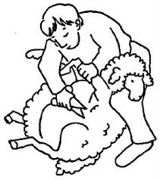**Shearing**

Sheep are sheared (or given a haircut) once a year in the spring. The entire coat of wool is cut from the sheep in one piece called a **fleece**. Shearing does not hurt the sheep. In fact, shearing helps sheep feel more comfortable because they cannot shed on their own.

The fleece is cleaned and processed into yarn to be used for clothing, blankets and even the inside of baseballs. **Lanolin**, the oil from the wool, is used in adhesive tape, printing inks and motor oils. Many cosmetics and beauty products such as lipstick, lotions and shampoos have lanolin in them.

**How Well Did You Read?**

**Circle ALL of the correct answers. There can be more than one!**

1. What do you call a female sheep?

ram flock ewe lamb

1. What do you call a group of sheep?

ram flock ewe lamb

1. What are some reasons farmers might raise sheep?

_________________________________________________________

_________________________________________________________

_________________________________________________________

1. What are some products we get from sheep?

meat clothes lipstick yarn

1. What does the word **graze** mean? (Choose one)

* to shear a sheep
* to eat grasses
* to flock together
* to run



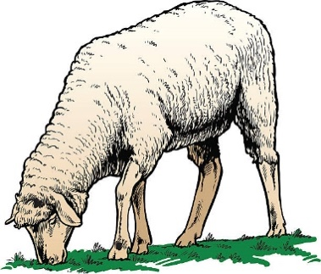

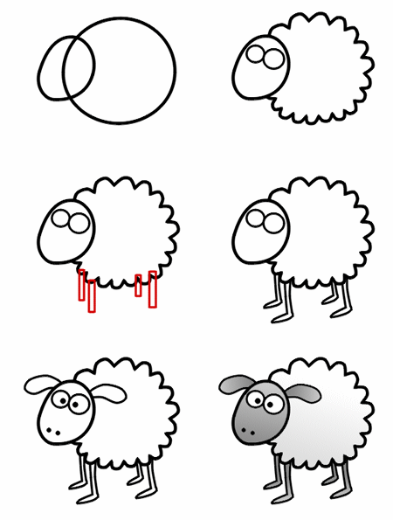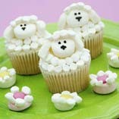

**Marshmallow Sheep Cupcakes**

**Ingredients**

* large white marshmallows
* mini white marshmallows
* tube of black writing icing
* 1container of frosting
* cupcakes

**Directions**

1. Spread a layer of frosting over the top of

the cupcake.

1. Leave a large glob of icing in the center.
2. Place a large marshmallow in the center

of the cupcake for the sheep’s face.

1. Have an adult cut another large

marshmallow in half horizontally and then

in half again. Stick 2 of these pieces on

either side of the sheep’s face to form the ears.

1. Have an adult cut several mini marshmallows

in half.

1. Arrange some halved mini marshmallows

on the top of the sheep’s head.

1. Place the rest of the cut mini marshmallows

around the top of the cupcake.

1. Draw eyes and noses on the sheep’s face

using the black writing icing.





­­­

**How to Draw a Cartoon Sheep**

Wool Trivia

* Wool is fire resistant.
* Wool can absorb up to 30% of its weight in moisture.
* A perfectly preserved wool sock was found buried in the silt along the banks of a river in England. The sock is estimated to be 1,000 years old.
* President Woodrow Wilson grazed sheep on the White House lawn. The wool obtained from the

sheep was sold to raise

money for the Red Cross

during World War I.

Joke Time

1. Where did the sheep go for a haircut?
2. Why are sheep baaad drivers?



* Vermont uses sheep to keep down vegetation on ski slopes during the summer.
* 73% of the wool produced is used in clothing and accessories, 15% in home furnishings and 7% in industrial felts used for noise reduction.
* One pound of wool can be spun into 900-1,200 yards of medium weight yarn.
* The top 5 sheep producing states are Texas, California, Wyoming,

Colorado and Utah (2020).

Did You Know …?

**Joke Answer:**

1. The baa baa shop
2. They always make illegal ewe turns.

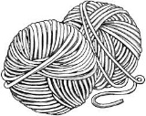

For more agricultural education lessons and resources, visit: **www.maefonline.com**