Ag Literacy Program 2016
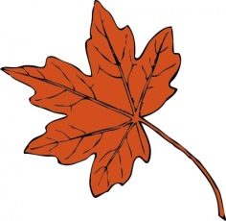
Learning about Maple Syrup
Web what you know about maple syrup. Where does it come from?
How is it made? What does it taste like? How is it eaten?
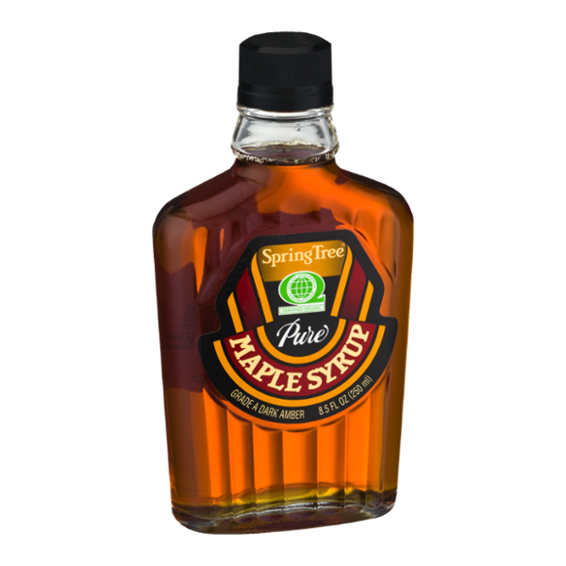

- True or False Maple syrup comes from maple leaves.

- True or False Nuts are used to make maple syrup.

- True or False Farmers can harvest maple syrup any time of the year.

- True or False A sugarhouse is a place where sugar is made.

- True or False A sugarbush is a farm that raises maple trees for their sap.

- Mayflower True or False The Pilgrims brought maple syrup with them on the because it wouldn’t spoil on the long trip.
Learning about Maple Syrup

Maple sap is a sweet water-like liquid that is collected from maple trees in late winter and early spring. The sap is collected when the night temperatures drop below freezing and the daytime temperatures are above freezing. This usually occurs in February, March and early April depending on where the trees are growing. Trees are usually 30-40 years old before they are tapped. Maple syrup is produced in North America with Vermont being the biggest producing state. A farm that raises maple trees for their sap is called a “sugarbush.”

A hole is drilled into the tree trunk. Next a small wooden or metal peg called a spile is put into the hole. The sap runs out of the spile and into a bucket or a plastic tube. As the temperature rises, the sap flows out of the tree. The sap is collected and sent to a “sugarhouse”.

At the sugarhouse, the sap is boiled down into maple syrup. It takes 40 gallons (a barrel) of sap to make one gallon of maple syrup. It takes 2-4 trees about 4-5 weeks to produce a barrel of sap.

Native Americans were the first “sugarmakers” and they taught the colonists the tree tapping process. In those days, the sap was collected in wooden buckets. It was then boiled outside in large cast iron kettles hung over a wood fire. Native Americans and the colonists usually made maple sugar instead of maple syrup because it was easier to store.

Today we enjoy maple syrup on French toast, pancakes, waffles and even oatmeal.
Learning about Maple Syrup Name:___________________

- Describe the sap that comes from a maple tree?

- Explain the conditions necessary for sap to be collected.

- What is the difference between a “sugarbush” and a “sugarhouse”?

- In colonial times, what do you think could have happened to the sap left in the buckets that were hanging on the trees?

- Explain whether you think it was better to collect the sap in buckets or have it travel through a plastic tube.

- Who first discovered maple syrup?
  - Columbus
  - George Washington
  - Native Americans
  - Colonists

- Create a drawing and label it to show – It takes 40 gallons of sap to make 1 gallon of maple syrup.

- Use the following pictures, to write a paagraph that describes the process if making maple syrup. Include details so the reader will understand how sap becomes syrup. Title your writing From Sugarbush Farm to Table.
