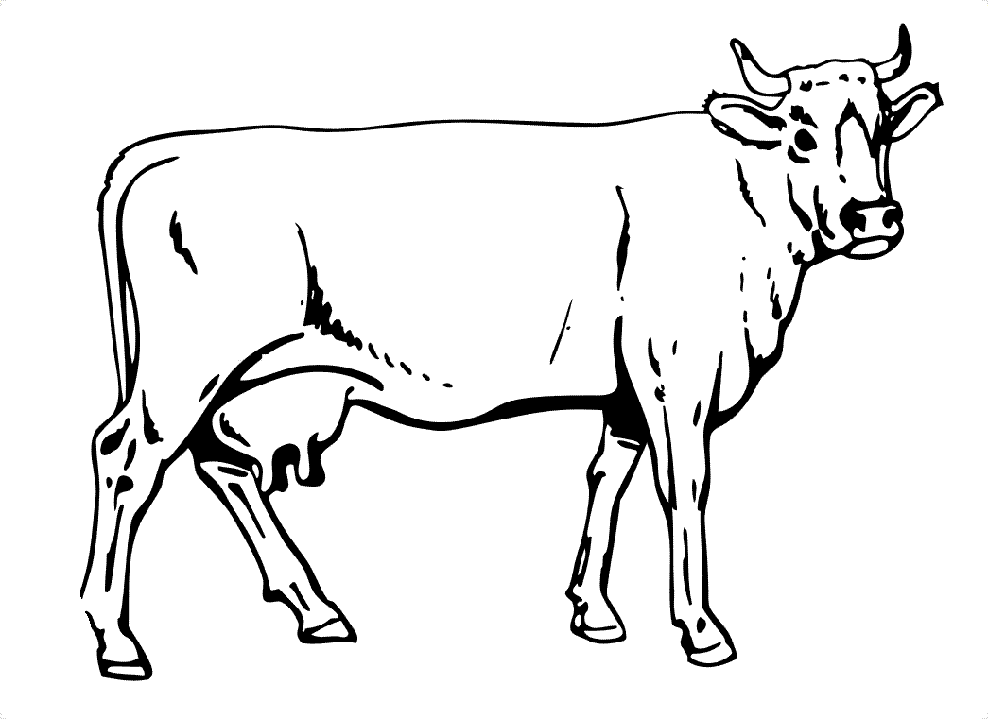

**Directions:**

1. **Mark your cow with black spots to show it is a Holstein cow.**
2. **Label the *udder***
3. **Draw an ear tag so the farmer knows which cow it is**
4. **Label – *tail* for swatting flies**
5. **In the each pitcher, add 10 dots – one for each glass of milk a cow produces.**
6. **On back, draw at least three (3) things made from milk.**



**A Holstein Dairy Cow Name:**

