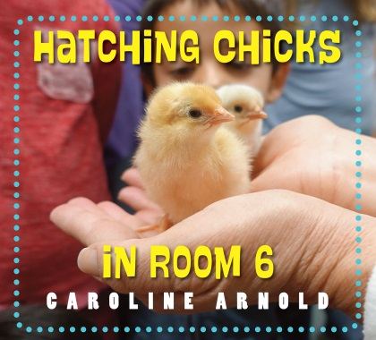
Hatching Chicks in Room 6 by Caroline Arnold

3. How fresh is an egg?

Overview
Eggs will react differently in water according to their age. This experiment will help students use their observation skills to determine how fresh an egg is.

Materials needed:
- Bowl of cold water deep enough to cover eggs
- Several eggs of different ages to test their freshness

Test to see if eggs are fresh

a. Fill a fairly deep bowl with water. The level of the water should be approximately twice the height of the egg. Then, carefully lower the egg into the bowl.
b. There are three things that could happen:
- A very fresh egg will immediately sink to the bottom and lie flat on its side. This is because the air cell within the egg is very small. The egg should also feel quite heavy.
- A slightly older egg (one week old) will still lie on the bottom of the bowl but at a slight angle. It will bob up and down rather than lie still.
- Older eggs will start to lose their freshness and as more air enters the egg, it will begin to float and stand upright. The smaller end will lie on the bottom of the bowl, while the broader end will point towards the surface. However, the egg will still be good enough to consume. Here, the egg is about three weeks old.
- Finally, if the egg fully floats in the water and does not touch the bottom of the bowl at all, it should be discarded, as it will most likely be bad.
www.maefonline.com

